**Predicting Income Levels**



>50,000 $ per year

Income Levels

Income

<=50,000 $ per year

**Problem Definition:**

**Objective:** The goal is to predict whether a person makes over $50,000 per year based on their demographic and socio-economic information.

**Data Context:**

* The data comes from the 1994 Census Bureau.
* Records were filtered to include people who are over 16 years old, have an income above $100, have a final weight greater than 1, and work more than 0 hours per week.

**Key Term:**

* **Final Weight (fnlwgt):** This number adjusts the records to accurately represent the population of the US. It's calculated using:
  1. Population estimate for each state.
  2. Estimates based on Hispanic origin, age, and sex.
  3. Estimates based on race, age, and sex. These weights ensure the data reflects the actual population accurately.

**Task:** Build a model to classify people into two groups:

1. Those who earn more than $50,000 per year.
2. Those who earn $50,000 or less per year.

**Data Attributes:** The dataset includes features like:

* Age
* Type of job
* Education level
* Marital status
* Job type
* Relationship status
* Race
* Sex
* Capital gains and losses
* Hours worked per week
* Country of origin

**Challenges:**

* Balancing the number of high-income and low-income individuals.
* Avoiding bias in the model towards any specific demographic group.
* Using the final weight (fnlwgt) correctly in the model.

The aim is to create a model that can accurately predict if someone makes over $50,000 based on their background information.

**Importing the libraries:**

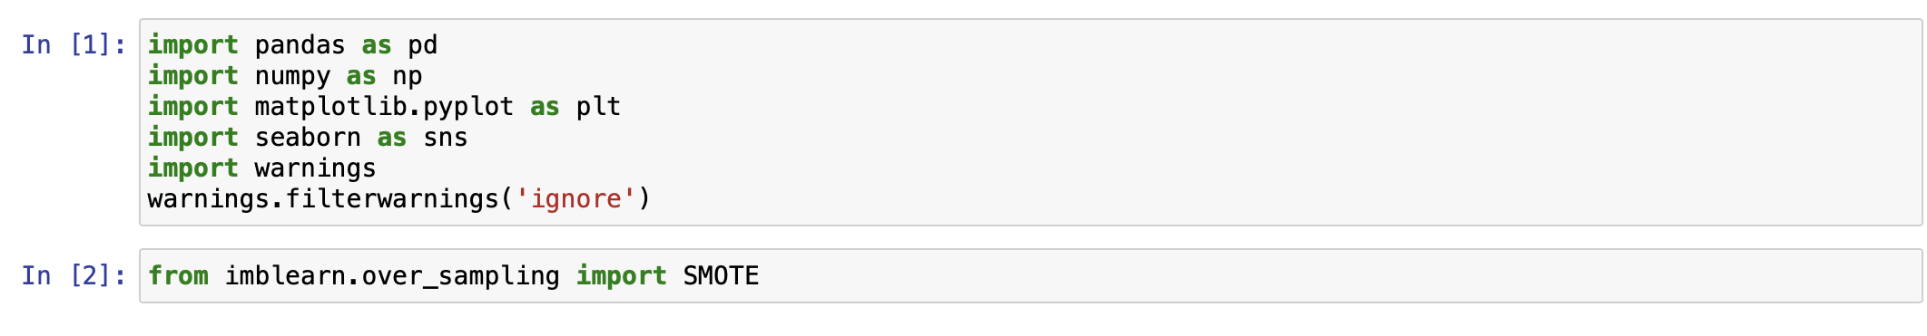

**Loading the data:**



**Data Analysis:**

* Checking the first 5 rows of the dataset

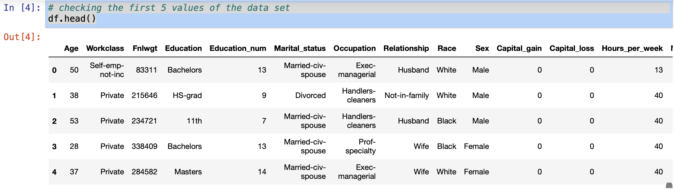

* Checking the last 5 rows of the dataset

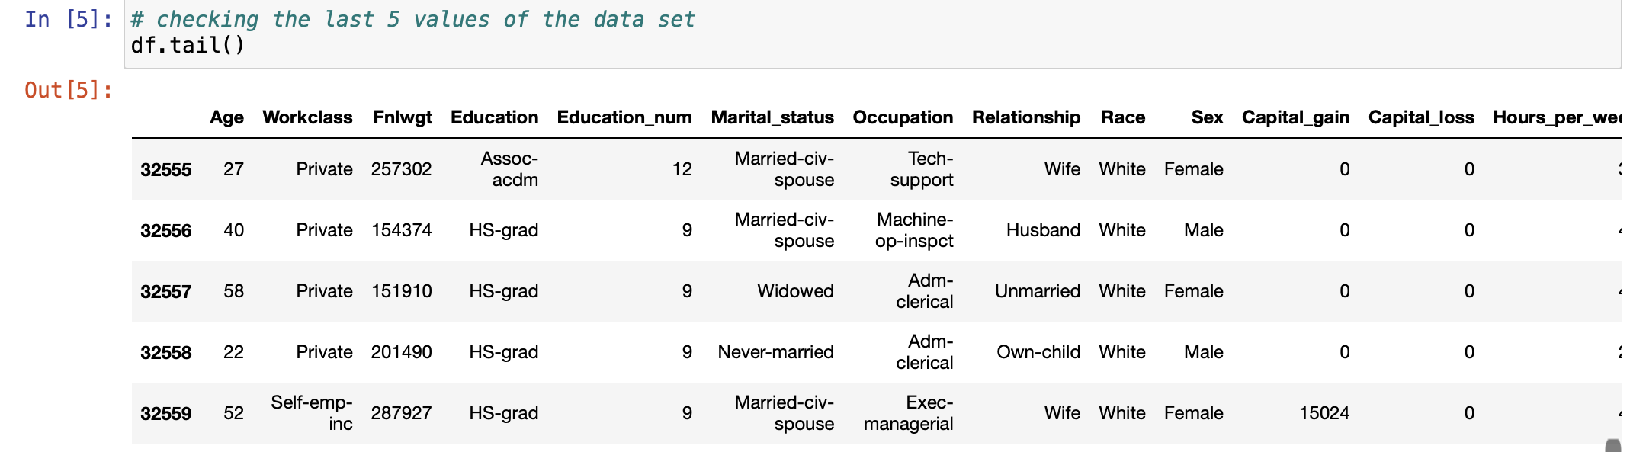

* Checking the any 10 sample rows of the dataset

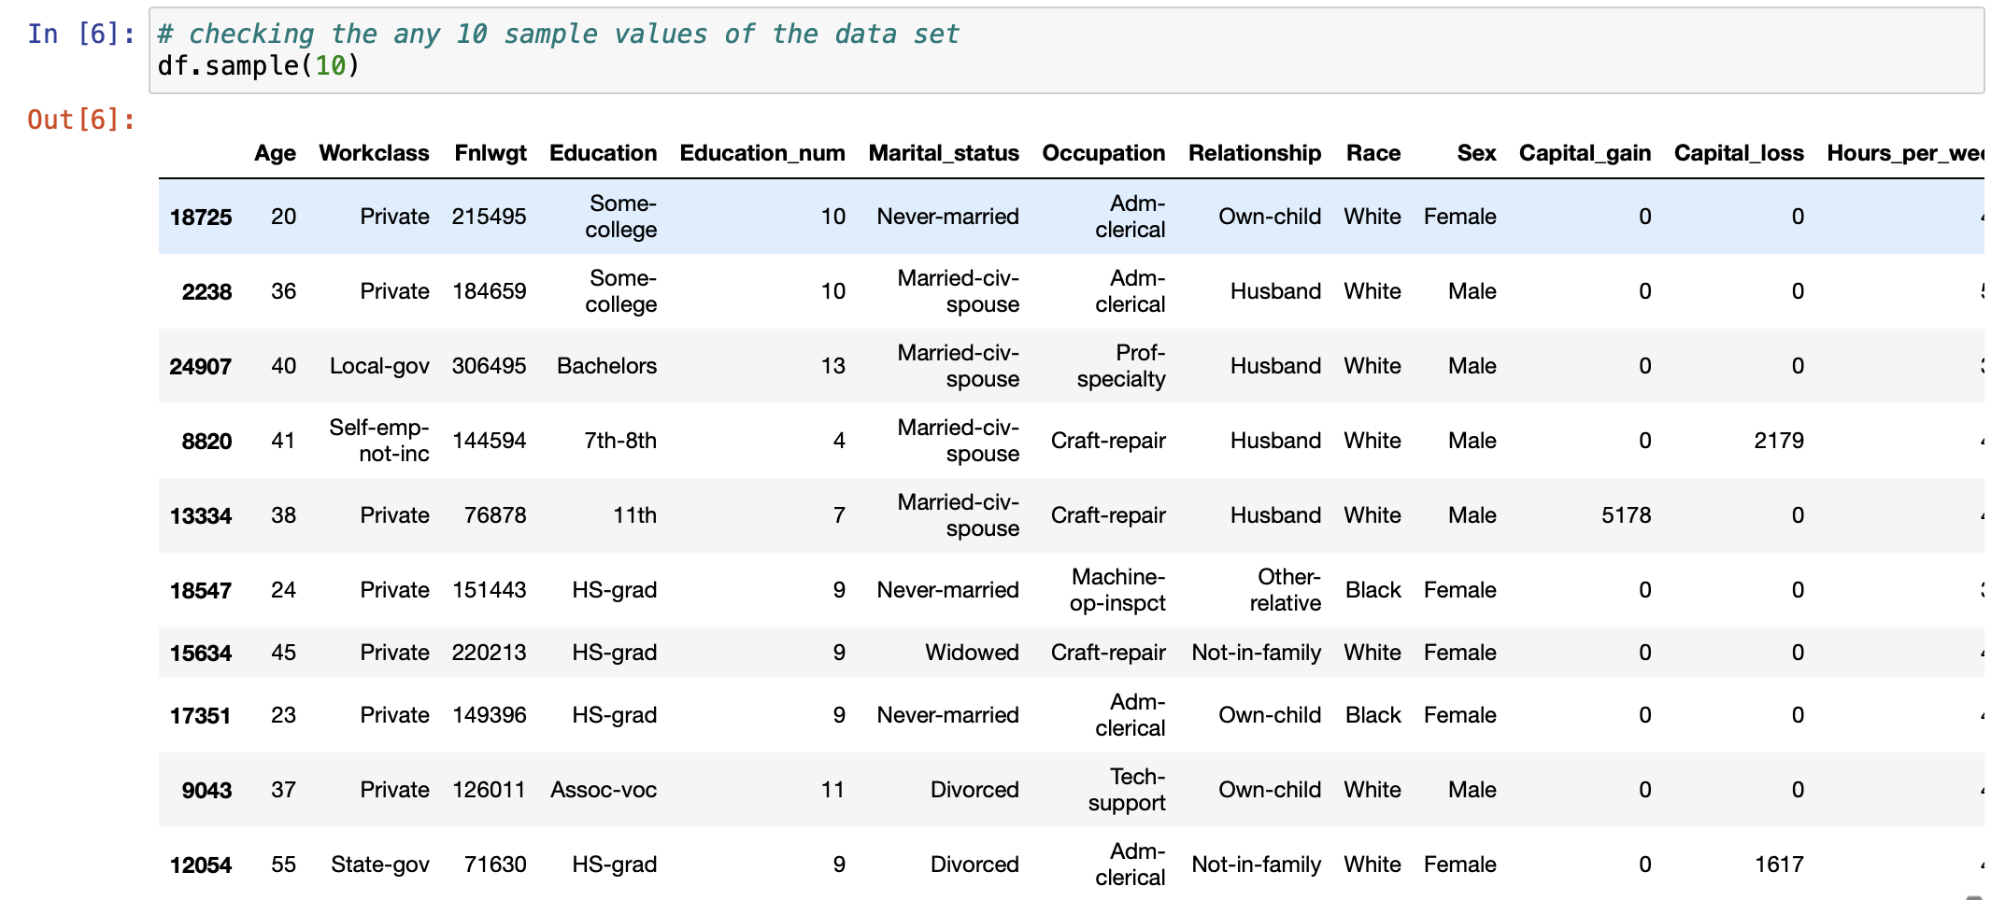

* Checking the columns ,shape, info and datatypes of the dataset:

The rows in the dataset is 32560 and the columns are 15. There are 15 features including the target variable. There are 9 object type features which we must encode in our future steps so that machine can understand.

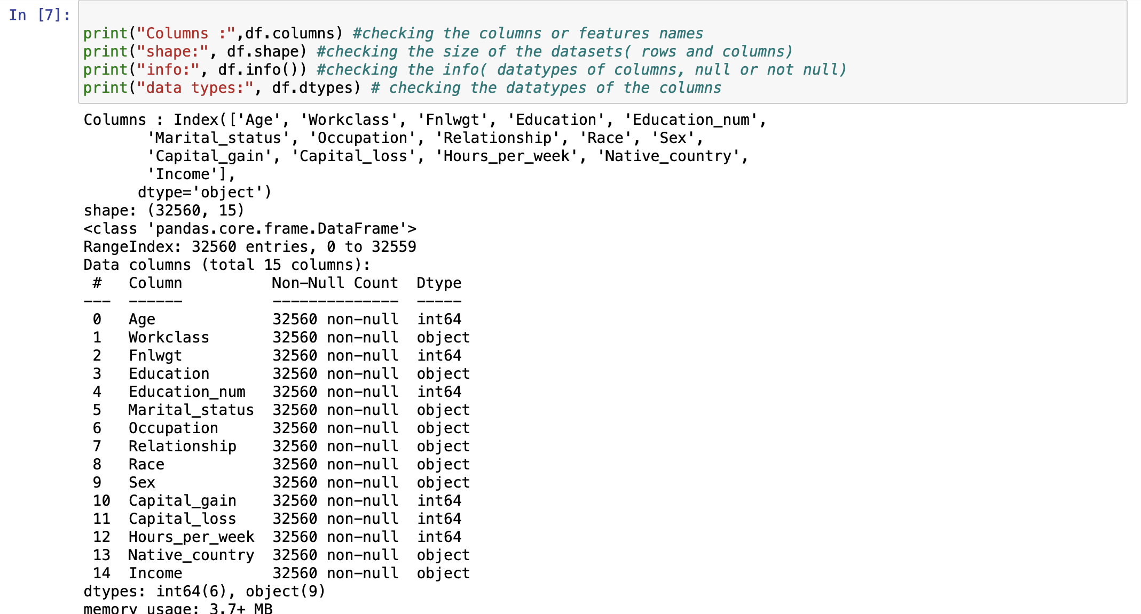

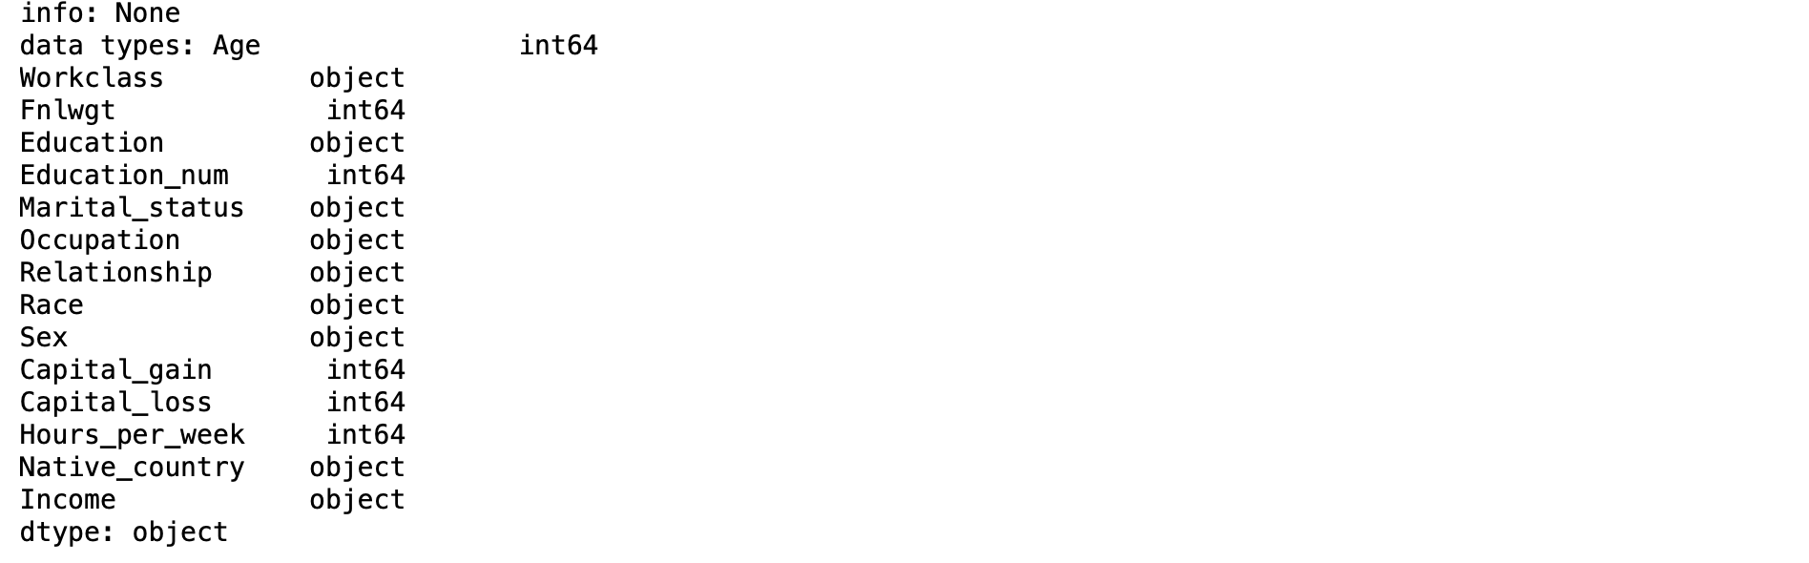

* Checking for null values in the dataset:

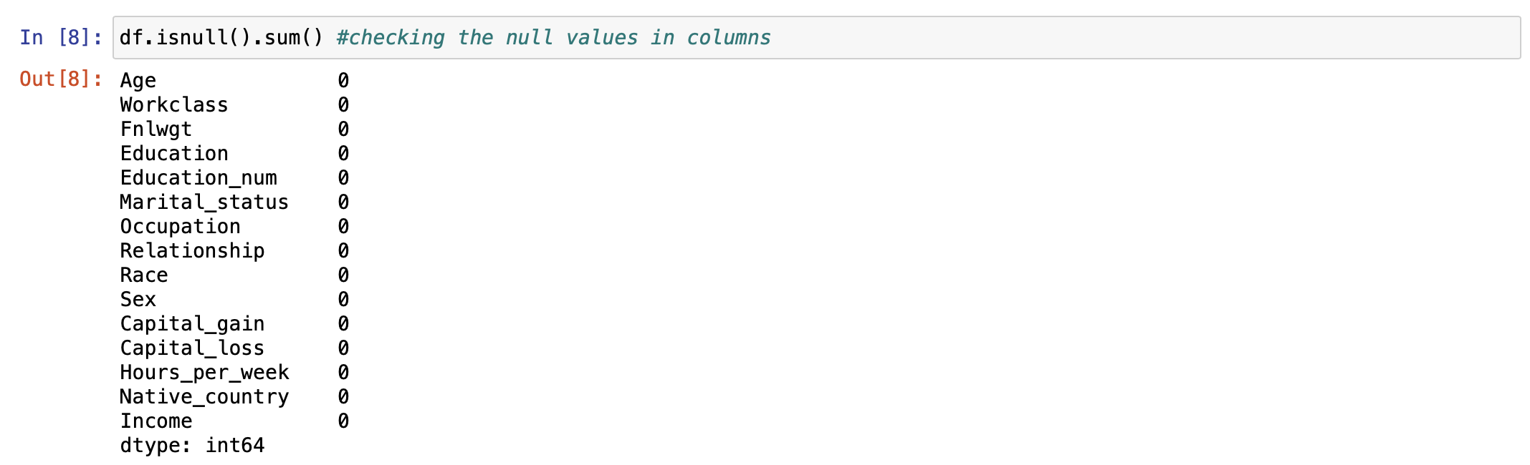



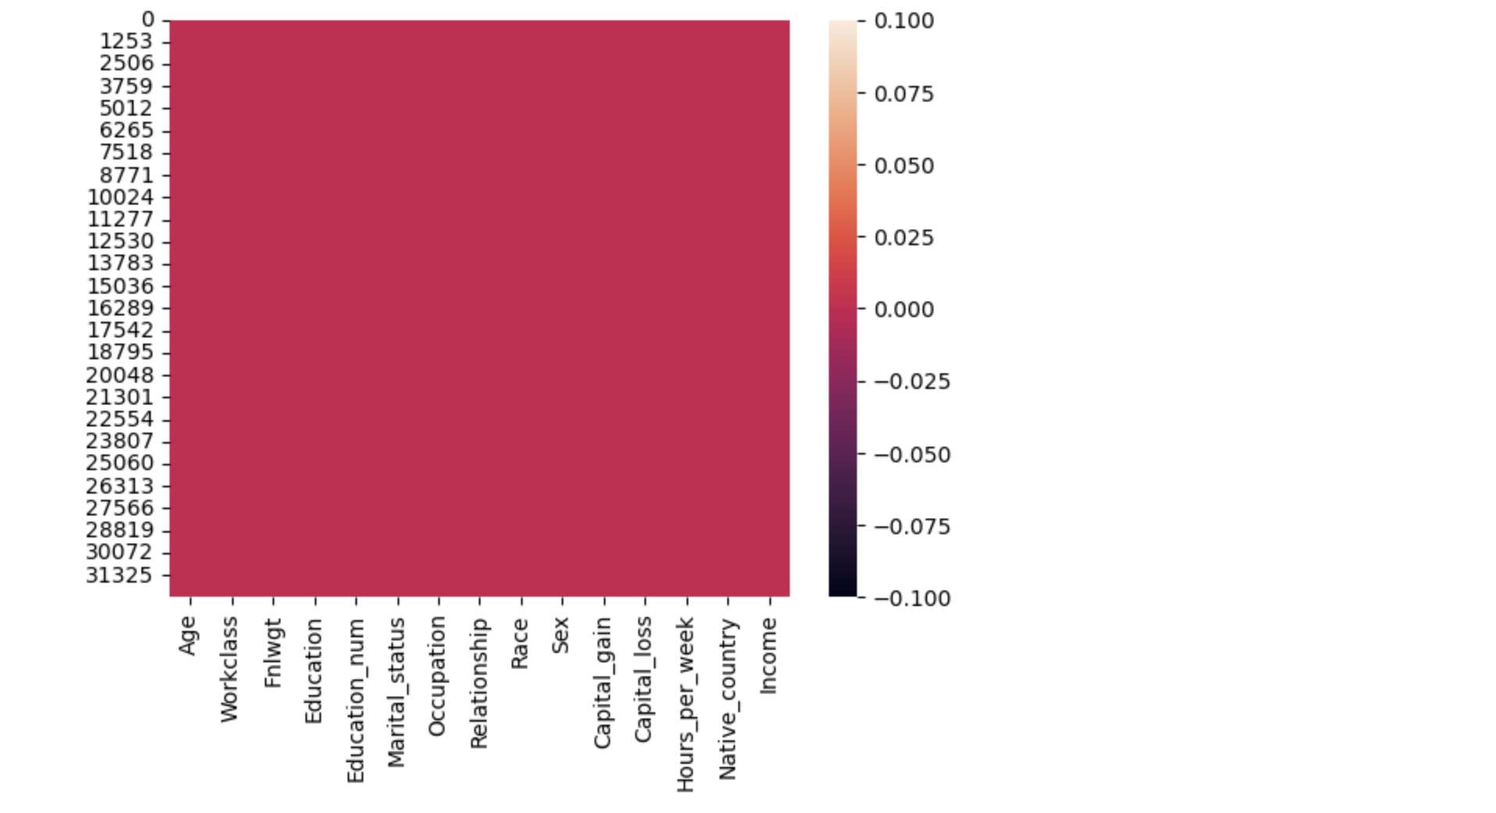

There are no null values present in our dataset.

* Checking for unique values of each column in the dataset:

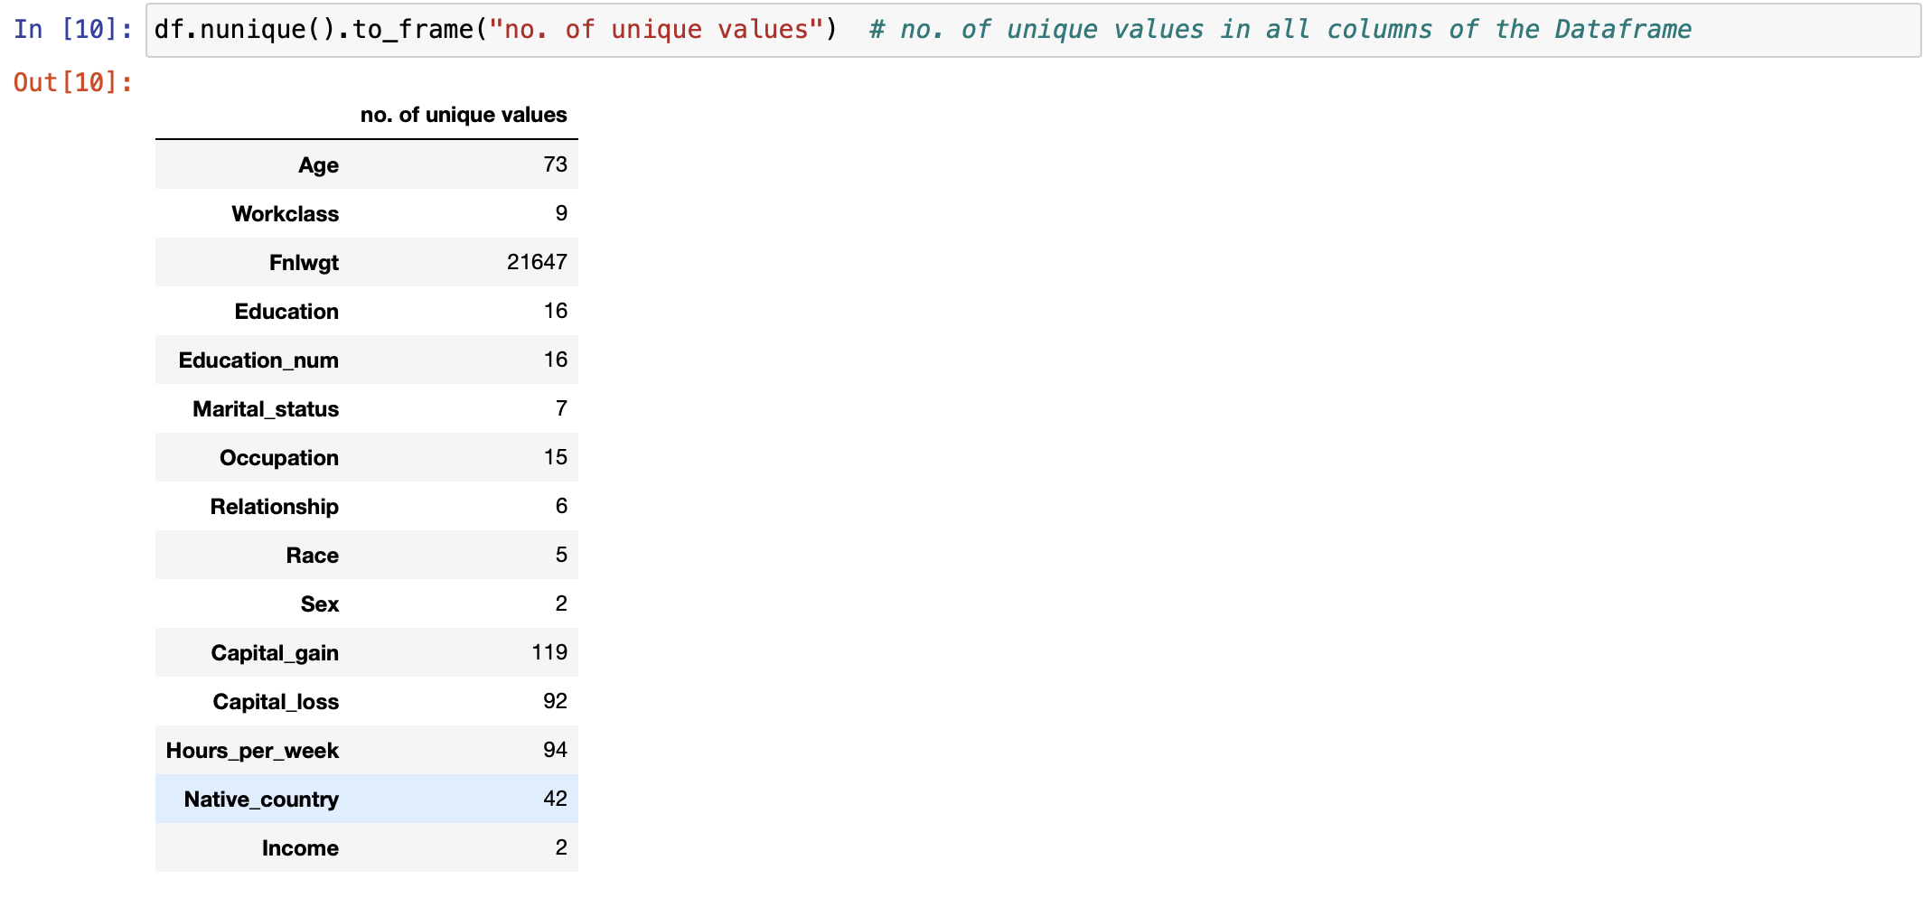

* Checking for missing values in the dataset: Missing values are present in the dataset. we replace the missing values to null values.

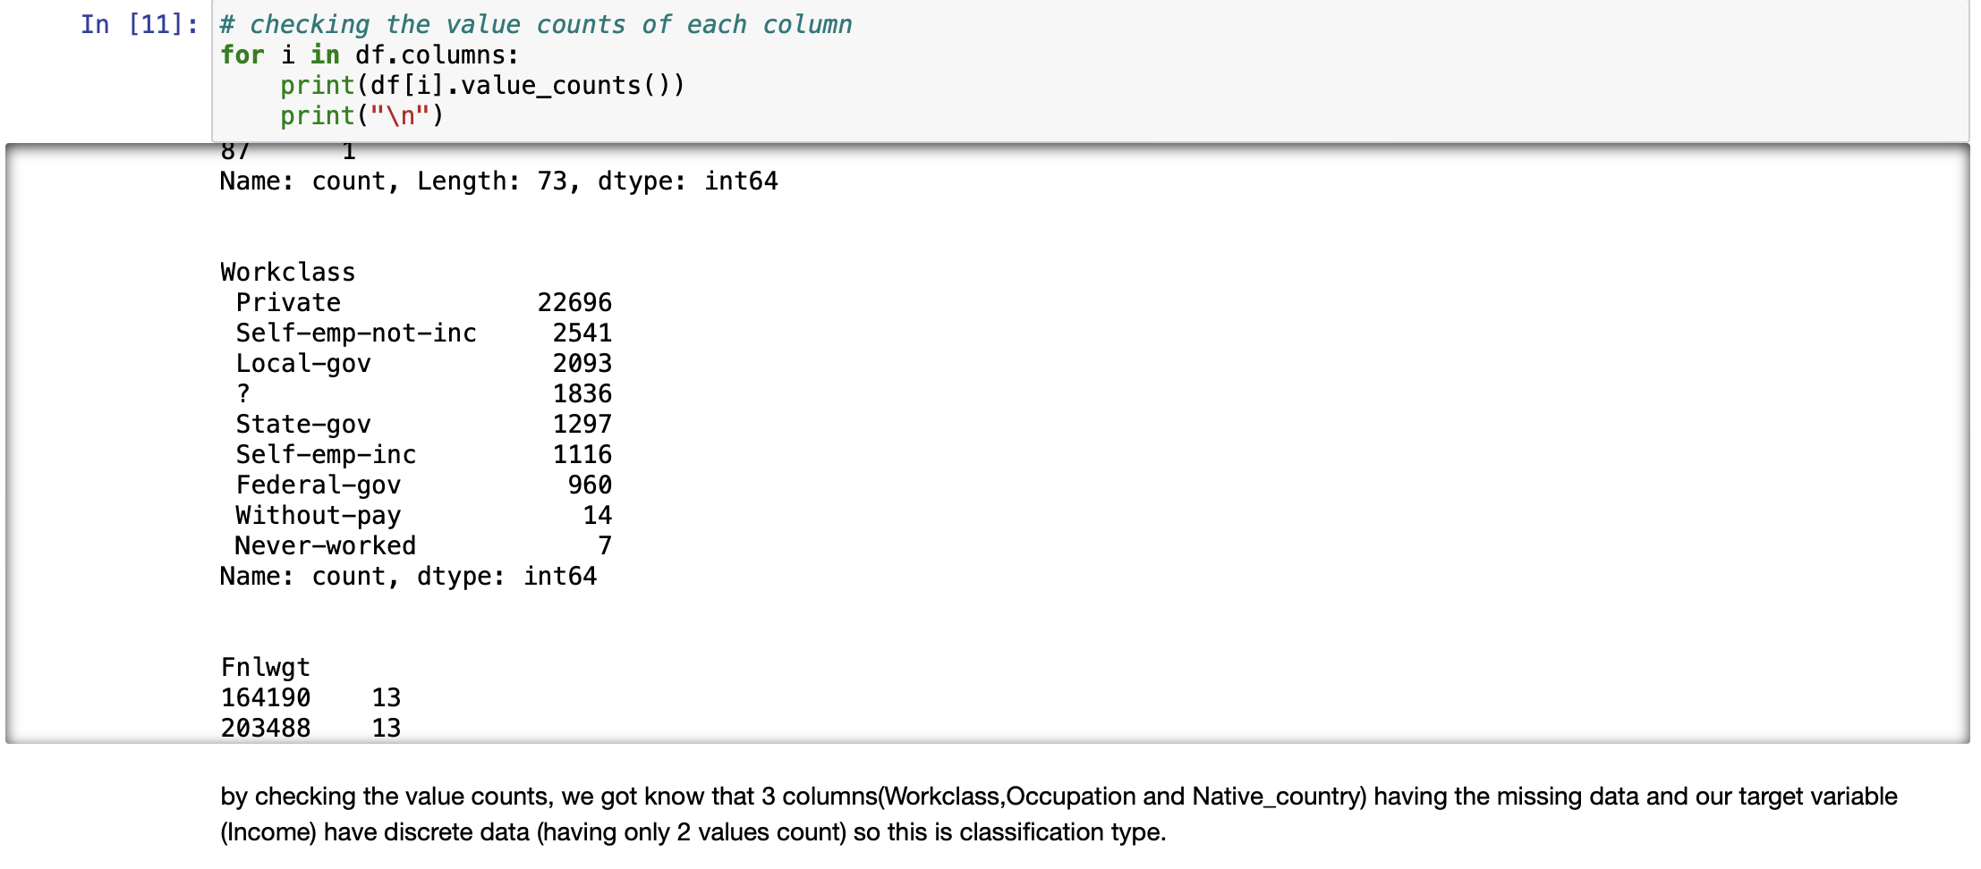

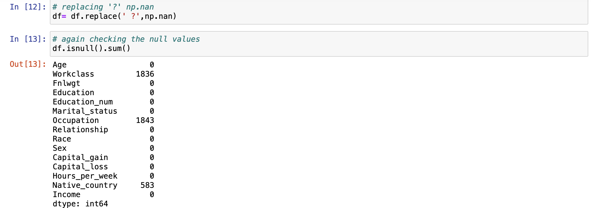

Now, There are null values present in our dataset due to replacing the missing values into null values which we must work on in our future steps to make our data clean and ready for machine building process.

Now we will start cleaning our data in our next steps so that we can build an efficient machine learning model.

**Data Pre-processing:**

1. For cleaning our data, we have to remove the null values present in our dataset, so I will be using SimpleImputer method for removing those values.

I am attaching a screenshot of my code where I have applied SimpleImputer to remove the null values. I have applied “mode strategy” for object type data.



We removed all the null values.

1. Now let’s check if any duplicate values are present in the dataset or not to remove.



24 duplicate rows are present in the dataset which we have to drop all the duplicated rows from the dataset.



Now let’s check if any duplicate values are left again to remove.



From the above screenshot, I can say that duplicate values are not present in the dataset now.

1. Checking the no. of zeros in the dataset:

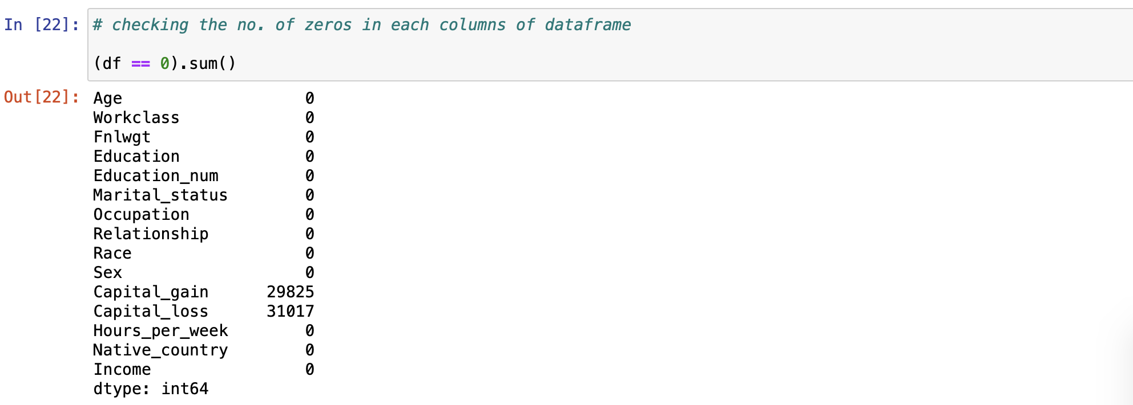

There are 2 columns ( Capital_gain and Capital_loss) which have the 29825 and 31017 out of 32536 zero values present in the column. It means that mostly column values are zeros in the particular column and these 2 columns are not useful for further building the model. So we can drop these 2 columns.



1. We have to check the duplicate column also. Let’s check it

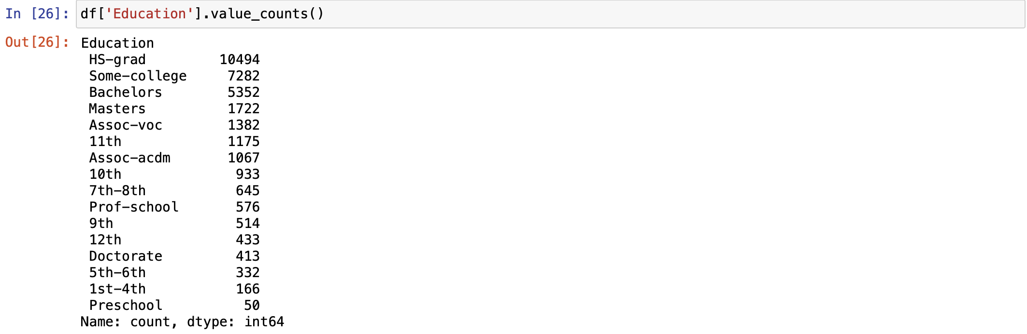

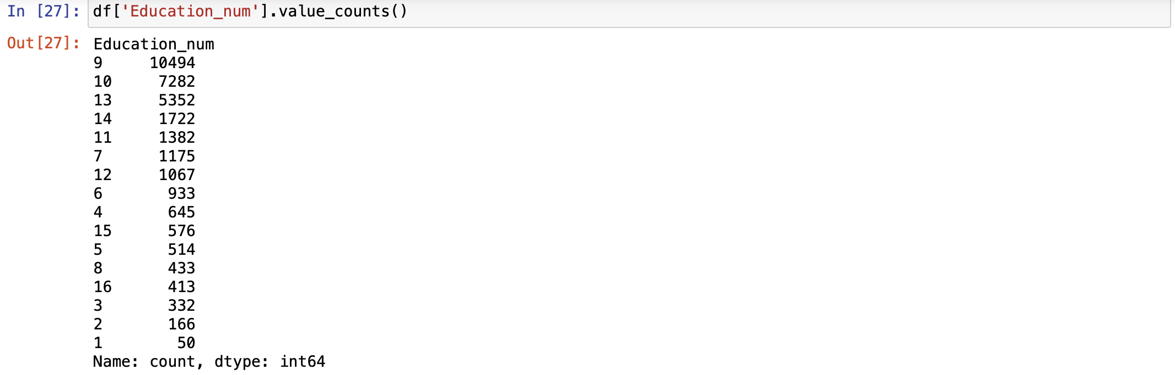

We have to drop the education feature Which is a duplicate feature of education_num. The matching education level of the education number:

1: Preschool, 2: 1st-4th, 3: 5th-6th, 4: 7th-8th, 5: 9th, 6: 10th, 7: 11th, 8: 12th, 9: HS-grad, 10: Some-college, 11: Assoc-voc, 12: Assoc-acdm, 13: Bachelors, 14: Masters, 15: Prof-school, 16: Doctorate



Again, we check the shape of our dataset.



Now, There are 32536 rows and 12 columns present in the dataset.

**Feature Engineering:**

1. Before doing the feature engineering, we have to segregate the categorical columns and numerical columns first.

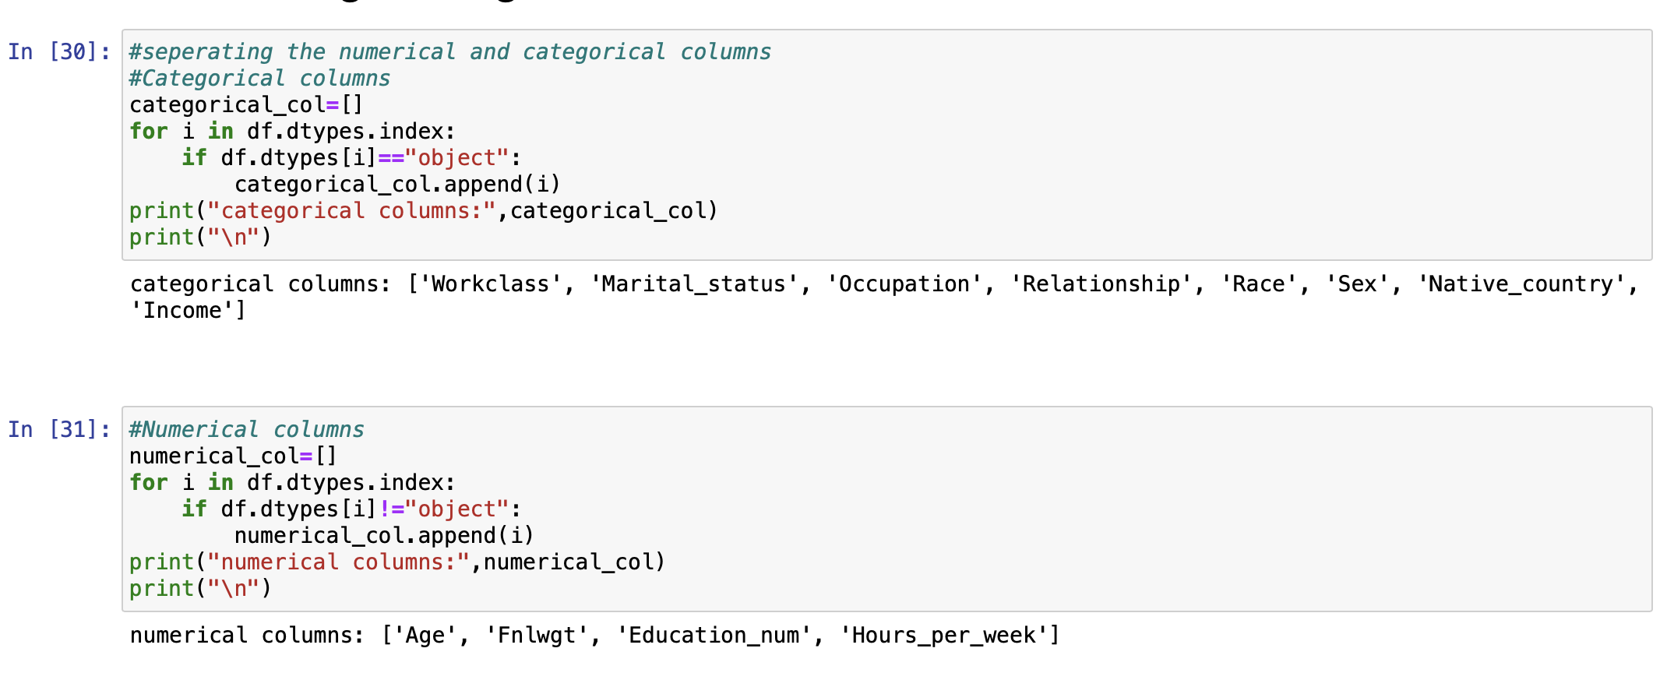

1. Let’s check the value counts of each columns:

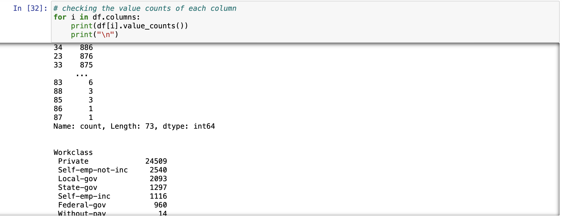

By checking the value count of each columns, we get to know that we can do the feature engineering of 2 columns i.e. Workclass and Martial_status for the building good model.

1. For Workclass feature:
   1. First check the value counts of the Workclass column

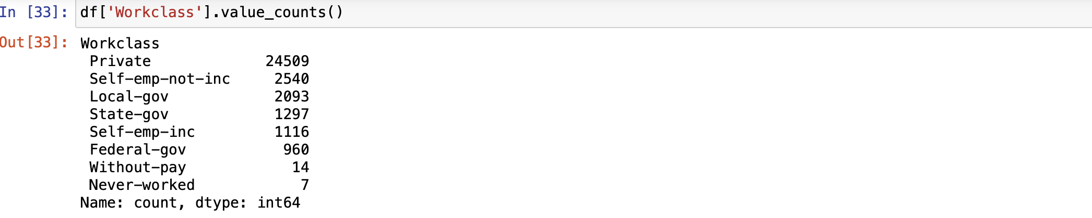

* 1. Do the feature engineering on the Workclass column



* 1. Again check the value counts of the Workclass column

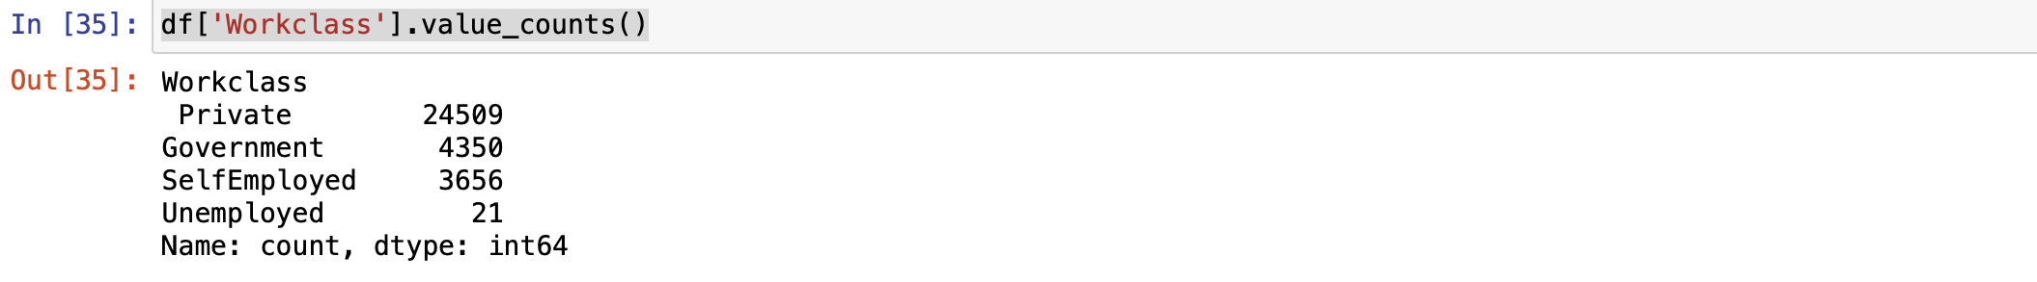

1. For Marital_status feature:
   1. Do the feature engineering on the Workclass column



* 1. check the value counts of the Workclass column

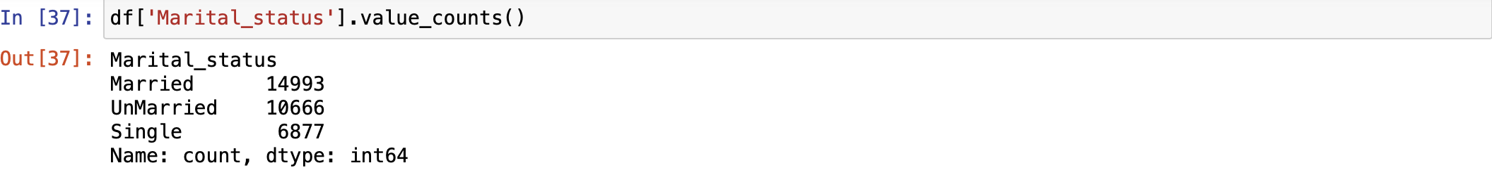

**Data Visualization:**

1. **Univariate Analysis:** 
   * 1. I have tried to visualize my categorical data using distplot. I have taken only one feature and tried to draw the countplot for each categorical columns.

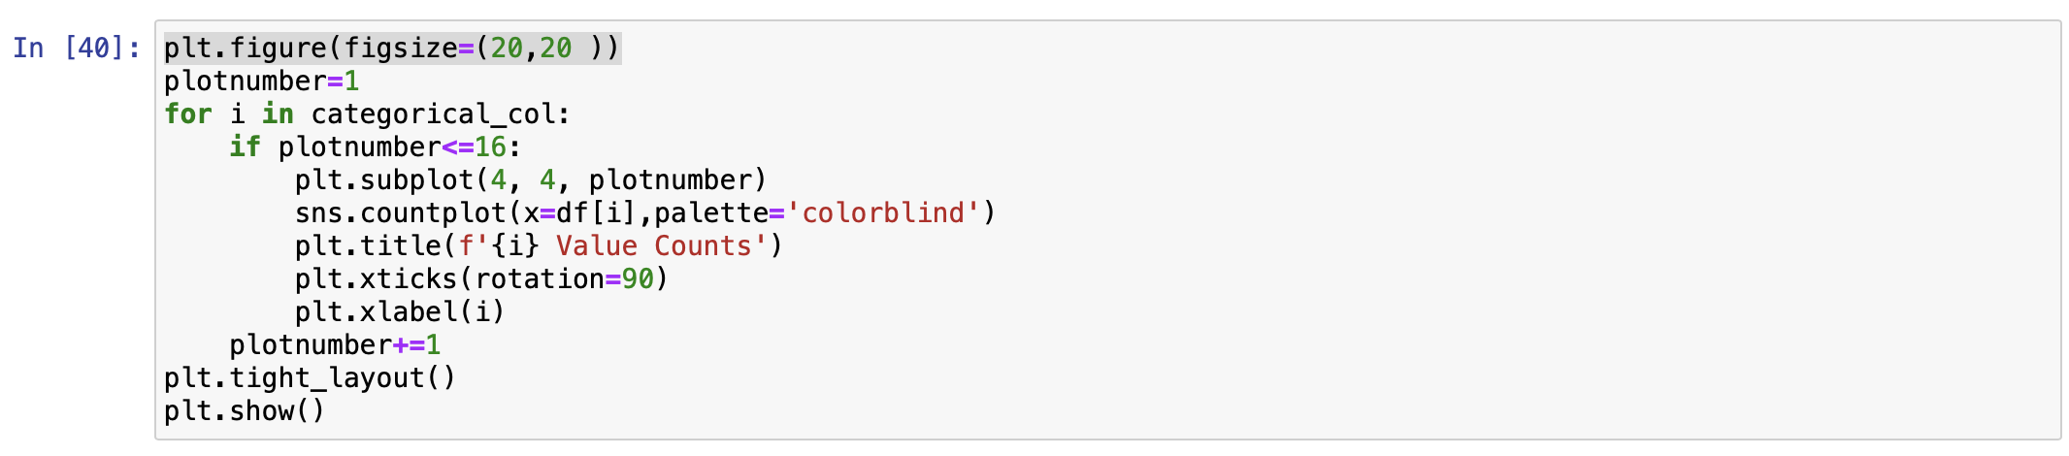

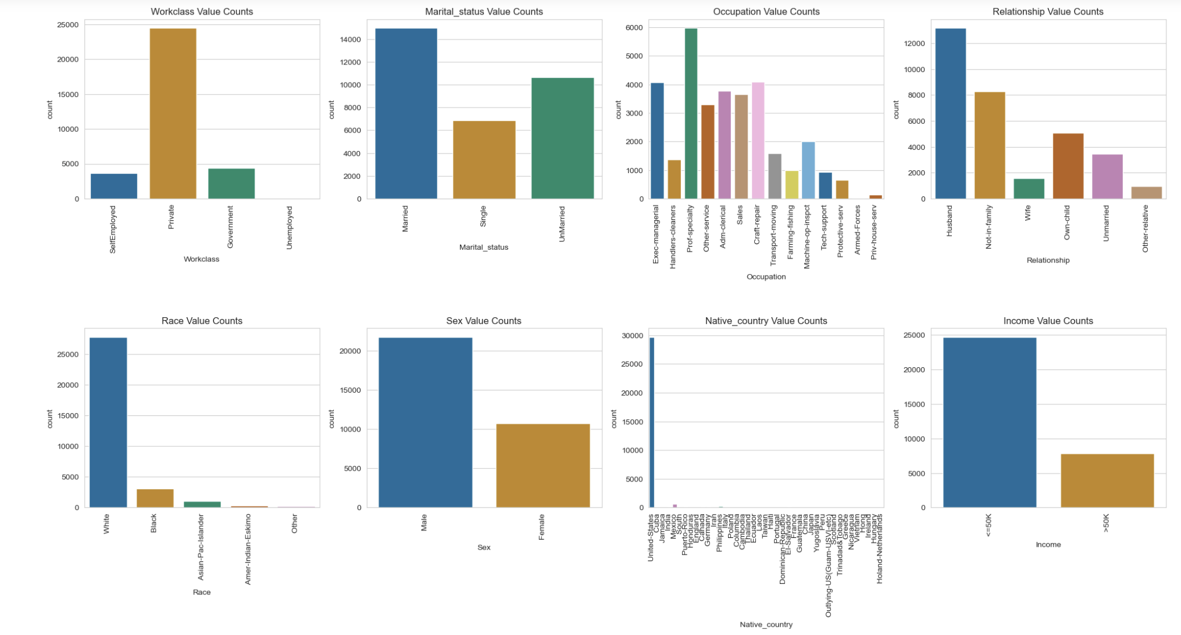

Observations:

Workclass - Mostly person worked in private sector as compared to other sectors.

Education - Majority of persons are at-least 12th pass-out in education than others.

Marital-status - The person who married are more compare than the persons who not-married. The count of single persons is above 6000.

Occupation - The count of individuals working as a Prof-specialty is highest in the data followed by individuals working as a Craft-repair > Exec-managerial > Adm-clerical > Sales > Other-service.

Relationship - Males as husband is approx. 13200 followed by persons not-in-family as compared to other individual's relationship.

Race - The no of white persons is highest.

Sex - The number of females is almost half of the males.

Native-country - Mostly persons belong to United-States.

Income - The majority of persons have income >=50k.

* + 1. I have tried to visualize my numerical data by using histplot. I have taken only one feature and tried to draw the histplot for each numerical columns.

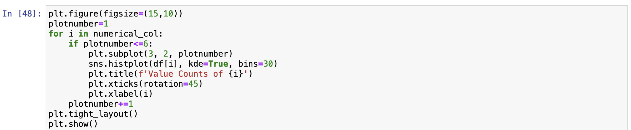

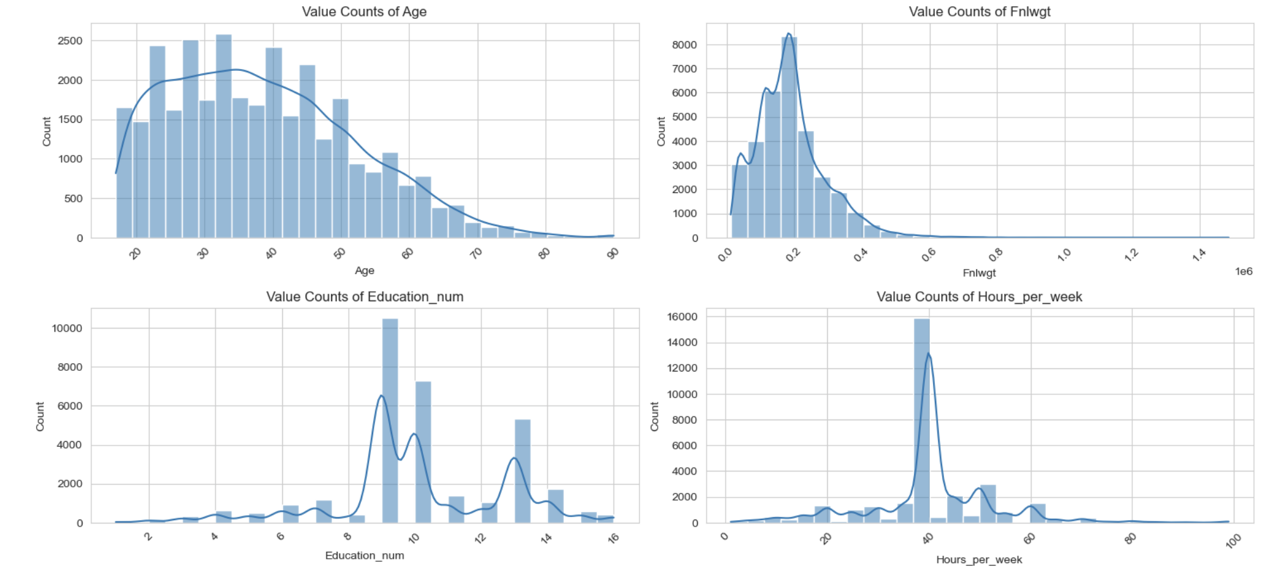

* + 1. I plot the countplot for 2 numerical columns also i.e Education_num and Hours_per_week.

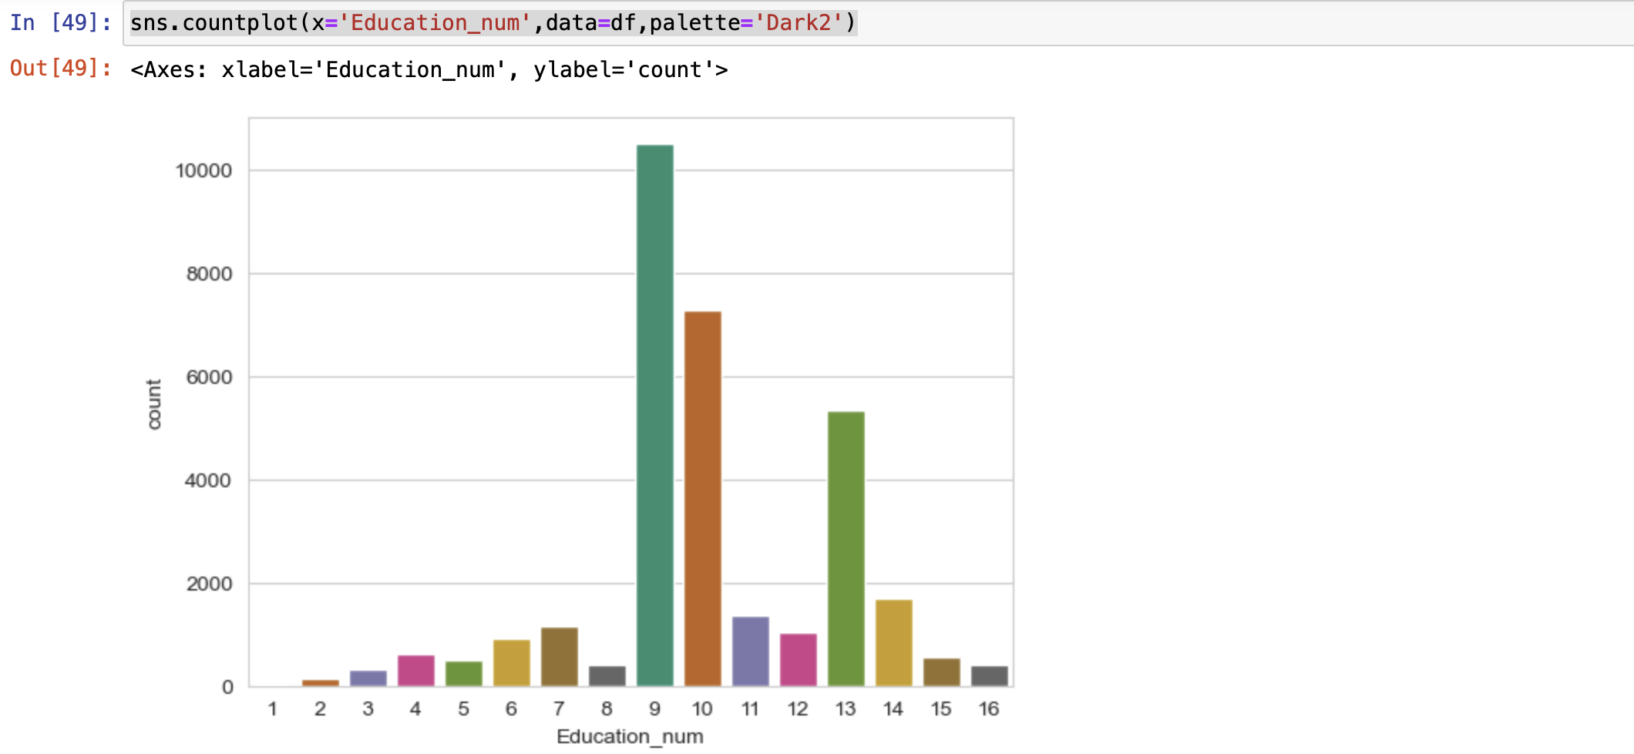

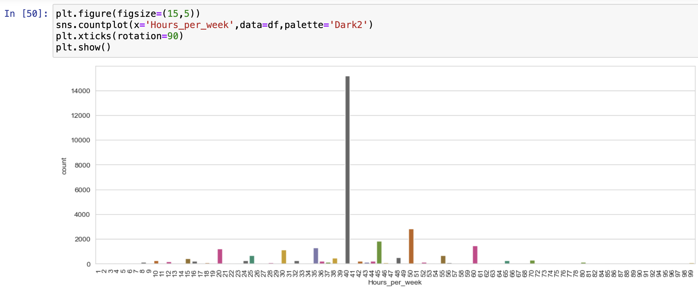

In these countplot, we found (i) in Education_num plot that mostly people have completed atleast 9th level of education (HS-grad )followed by 10 then 13 & 14 level and (ii) in Hours_per_week plot that 40 is the highest count of Hours_per_week worked by the people.

1. **Bivariate Analysis:** I have tried to visualize my data using graphs. I have taken two features including target variable and tried to draw a link in between those variables.

(i) I will check the relation between ‘Age’ and ‘Income’ using barplot. Let’s see what the outcome of the plot will be.

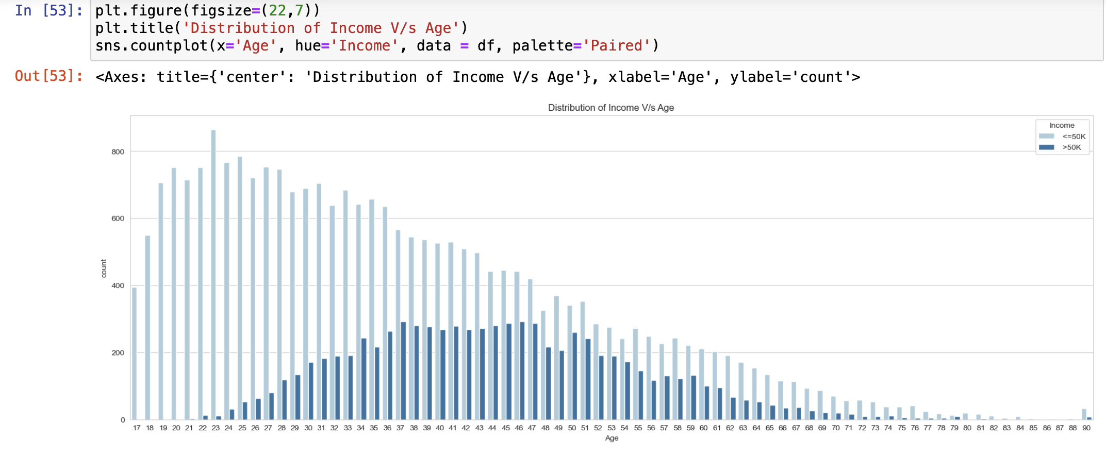

In this barplot, we can see that

1. The count of individuals decreases with age. The younger age groups (late teens to early 30s) have higher counts compared to the older age groups.

2.younger individuals (particularly between ages 19 to 28) are more likely to earn <=50K, while those in their middle ages (30-55) have a higher likelihood of earning >50K.

3.The overall trend shows a decrease in counts for both income categories as age increases, with a sharper decline in the higher income category in older age groups.

(ii) I will check the relation between ‘Workclass’ and ‘Income’ using barplot. Let’s see what the outcome of the plot will be.

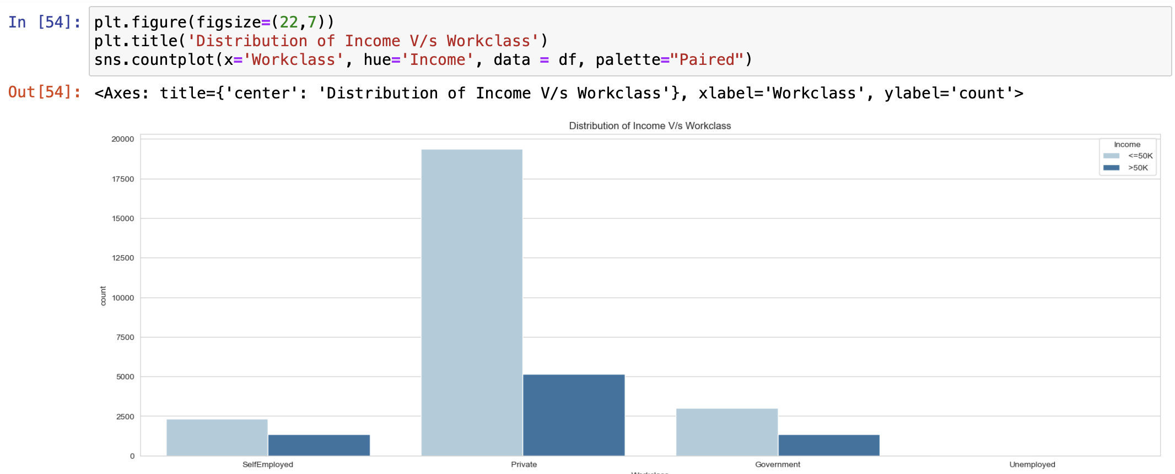

In this barplot, we can see that the Private sector has the highest number of individuals whose earning <=50K in majority compared to other work classes.

(iii) I will check the relation between ‘Education_num’ and ‘Income’ using barplot. Let’s see what the outcome of the plot will be.

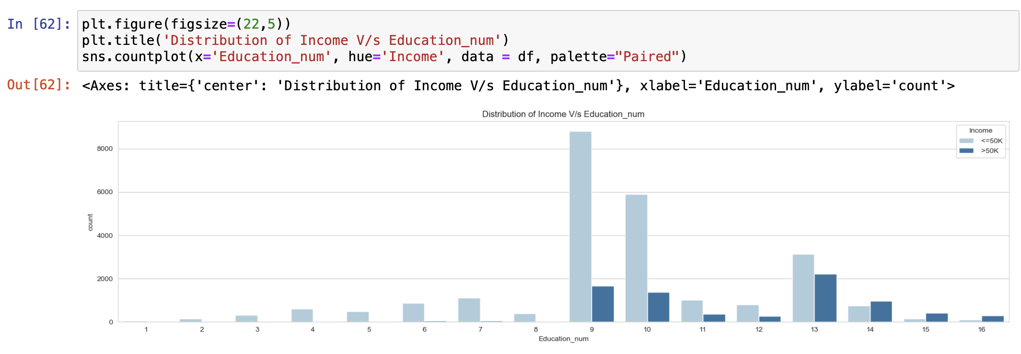

1: Preschool, 2: 1st-4th, 3: 5th-6th, 4: 7th-8th, 5: 9th, 6: 10th, 7: 11th, 8: 12th, 9: HS-grad, 10: Some-college, 11: Assoc-voc, 12: Assoc-acdm, 13: Bachelors, 14: Masters, 15: Prof-school, 16: Doctorate

In this barplot, we can see that

1.Preschool to 8th Grade: Predominantly earn <=50K with very few individuals earning >50K.

2.9th Grade to Some College: Majority earn <=50K, but the proportion of individuals earning >50K increases, especially from 10th grade onwards.

3.Associate Degrees to Doctorate: Higher likelihood of earning >50K, with Bachelor's and higher degrees showing a significant number of individuals in the >50K category. Bachelor's degree is the peak for higher income, followed by Master's, Professional School, and Doctorate degrees.

(iv) I will check the relation between ‘Martial_status’ and ‘Income’ using barplot. Let’s see what the outcome of the plot will be.

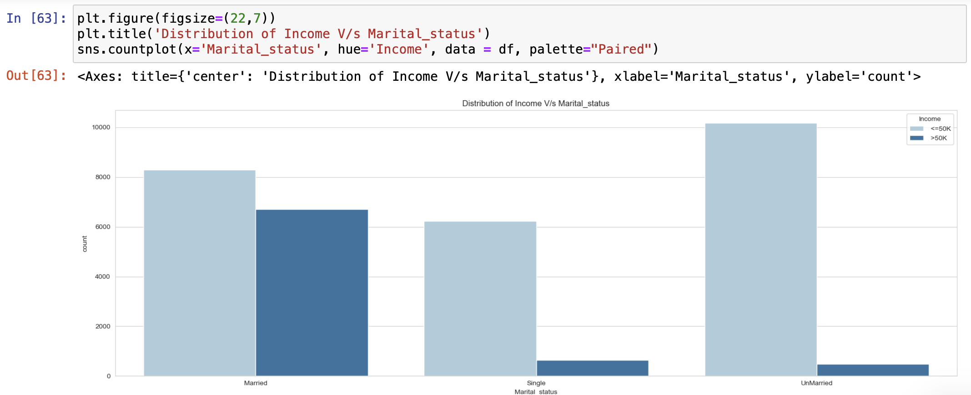

In this barplot, we can see that the marital status of being married is associated with a higher likelihood of earning >50K. Single and unmarried individuals are more likely to earn <=50K, with the unmarried category having the highest count of individuals earning <=50K.

(v) I will check the relation between ‘Occupation’ and ‘Income’ using barplot. Let’s see what the outcome of the plot will be.

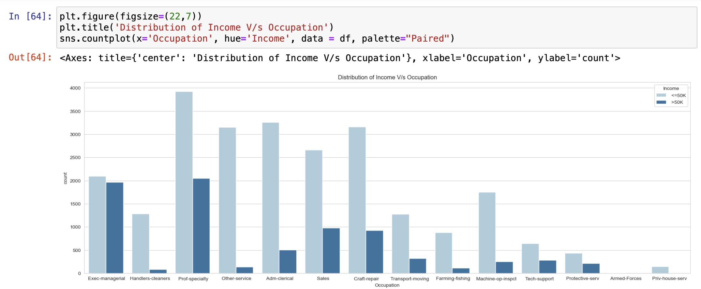

In this barplot, we can see that managerial and professional specialty occupations are associated with higher earnings, while service and manual labor occupations tend to have lower earnings.

(vi) I will check the relation between ‘Relationship’ and ‘Income’ using barplot. Let’s see what the outcome of the plot will be.

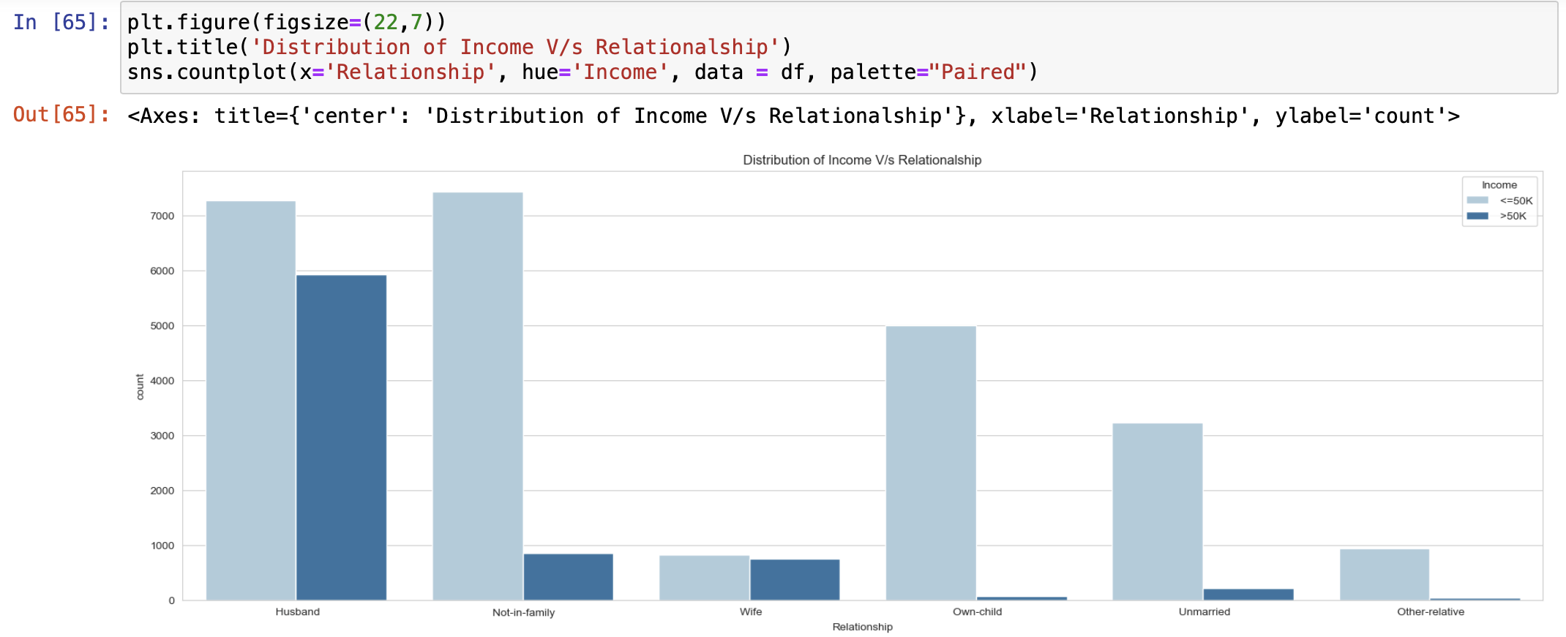

In this barplot, we can see that ‘Relationship’ as a husband is associated with a higher likelihood of earning >50K. Not-in-family relationship category having the highest count of individuals earning <=50K followed by husband, Own-child and unmaried.

(vii) I will check the relation between ‘Race’ and ‘Income’ using barplot. Let’s see what the outcome of the plot will be.

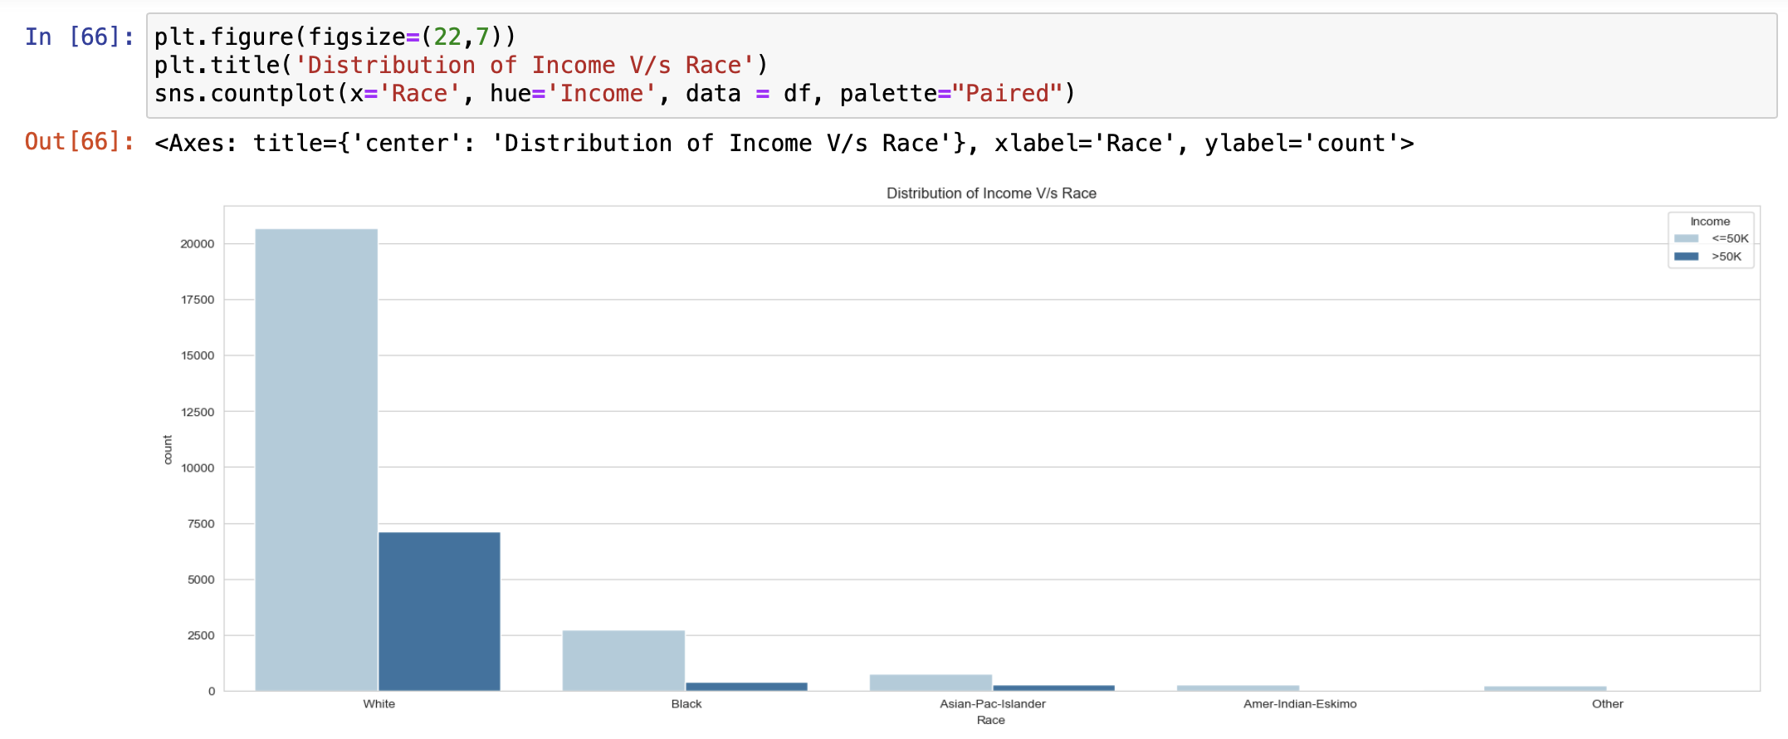

In this barplot, we can see that White people are the highest earning. Approx 7000 of white people earns more than 50k.

(viii) I will check the relation between ‘Native_country’ and ‘Income’ using barplot. Let’s see what the outcome of the plot will be.

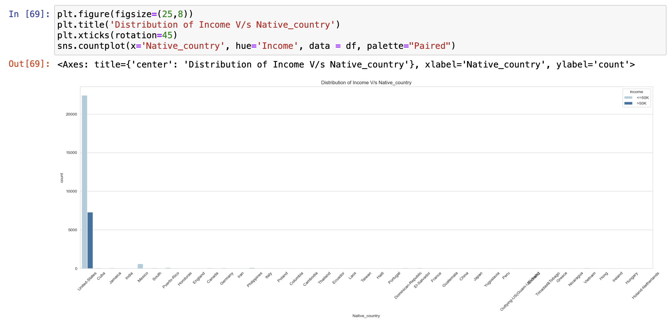

In this barplot, we can see that United States is the Native-country where the majority of individuals is earning <=50K than the individuals earning >50K and also the United -states have the highest count in both the income category than others native-countries.

(ix) I will check the relation between ‘Sex’ and ‘Income’ using barplot. Let’s see what the outcome of the plot will be.

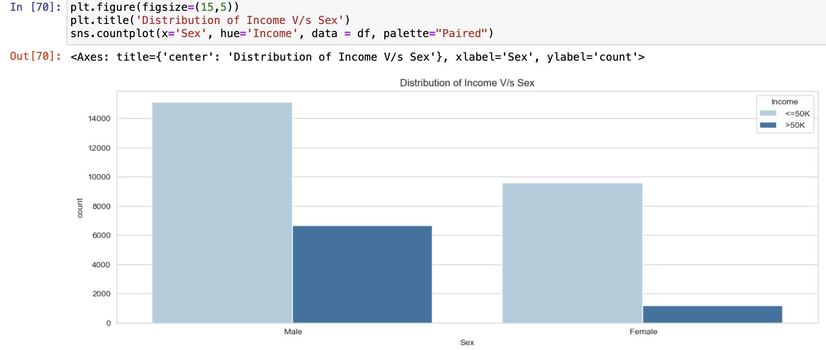

In this barplot, we can see that Males are earning higher income than females and majority of males are earning <=50K Income.

(x) I will check the relation between ‘Education_num’ and ‘Sex’ using barplot. Let’s see what the outcome of the plot will be.

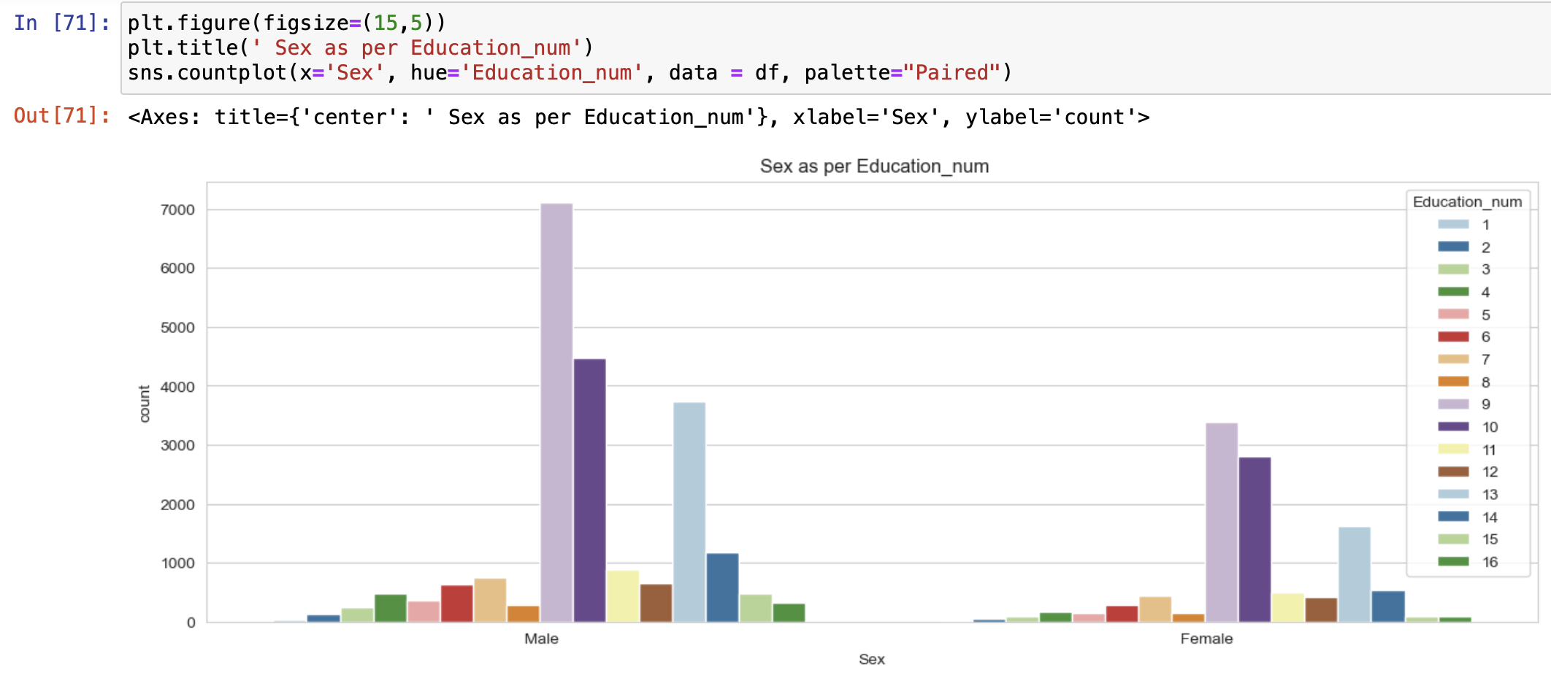

In this barplot, we can see that Males are more educated than females according to this dataset.

(xi) I will check the relation between ‘Sex’ and ‘Occupation’ using barplot. Let’s see what the outcome of the plot will be.

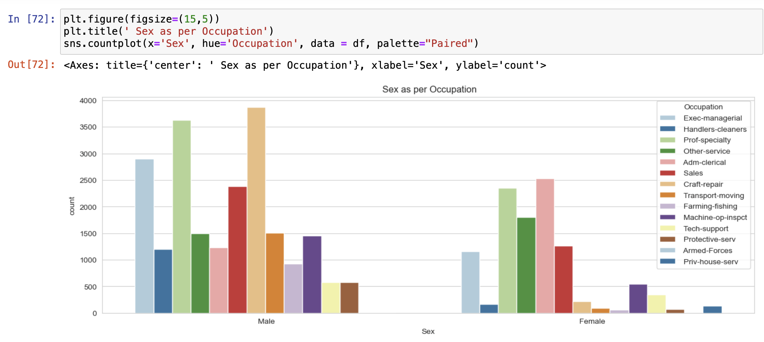

In this barplot, we can see that Males counts are more than female counts in each type of Occupation category.

**3. Multivariate Analysis:** I have tried to visualize my data using graphs. I have taken three features including target variable and tried to draw a link in between those variables.

(i) I will check the relation between ‘Income’ and ‘Age’ with ‘Sex’ using barplot. Let’s see what the outcome of the plot will be.

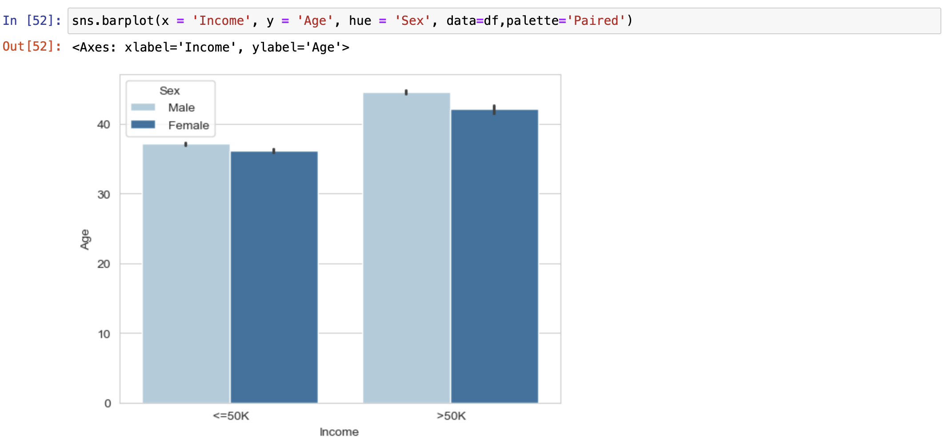

In this barplot, we can see that males whose age lie between 35-50 have higher salary than female in both income levels.

(ii) I will check the relation between all the columns with each other and with the target variable ‘Income’ . Let’s see what the outcome of the plot will be.



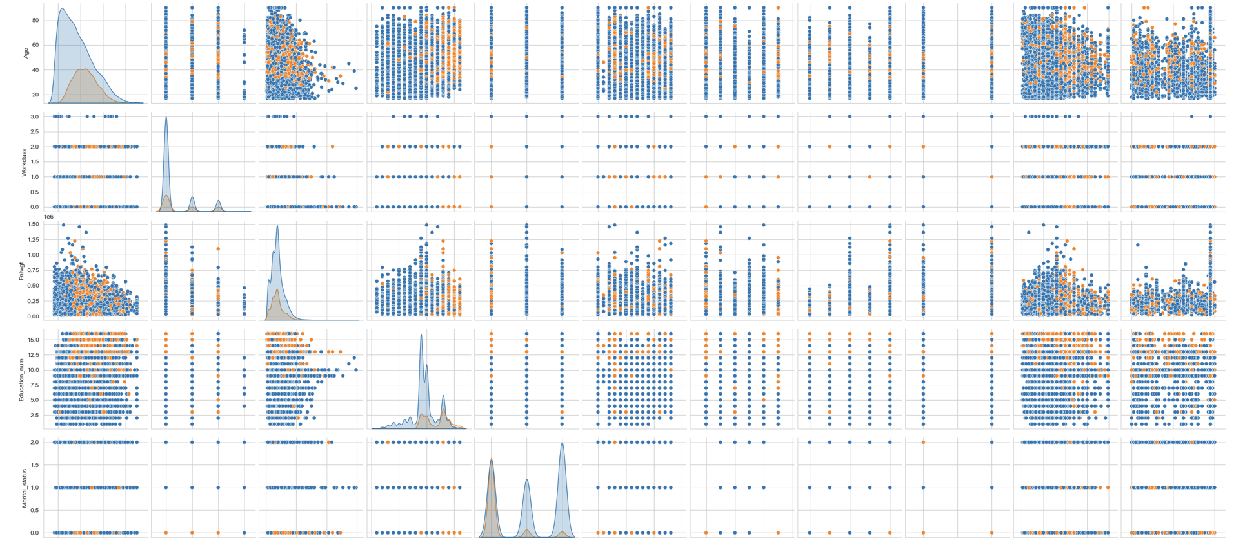

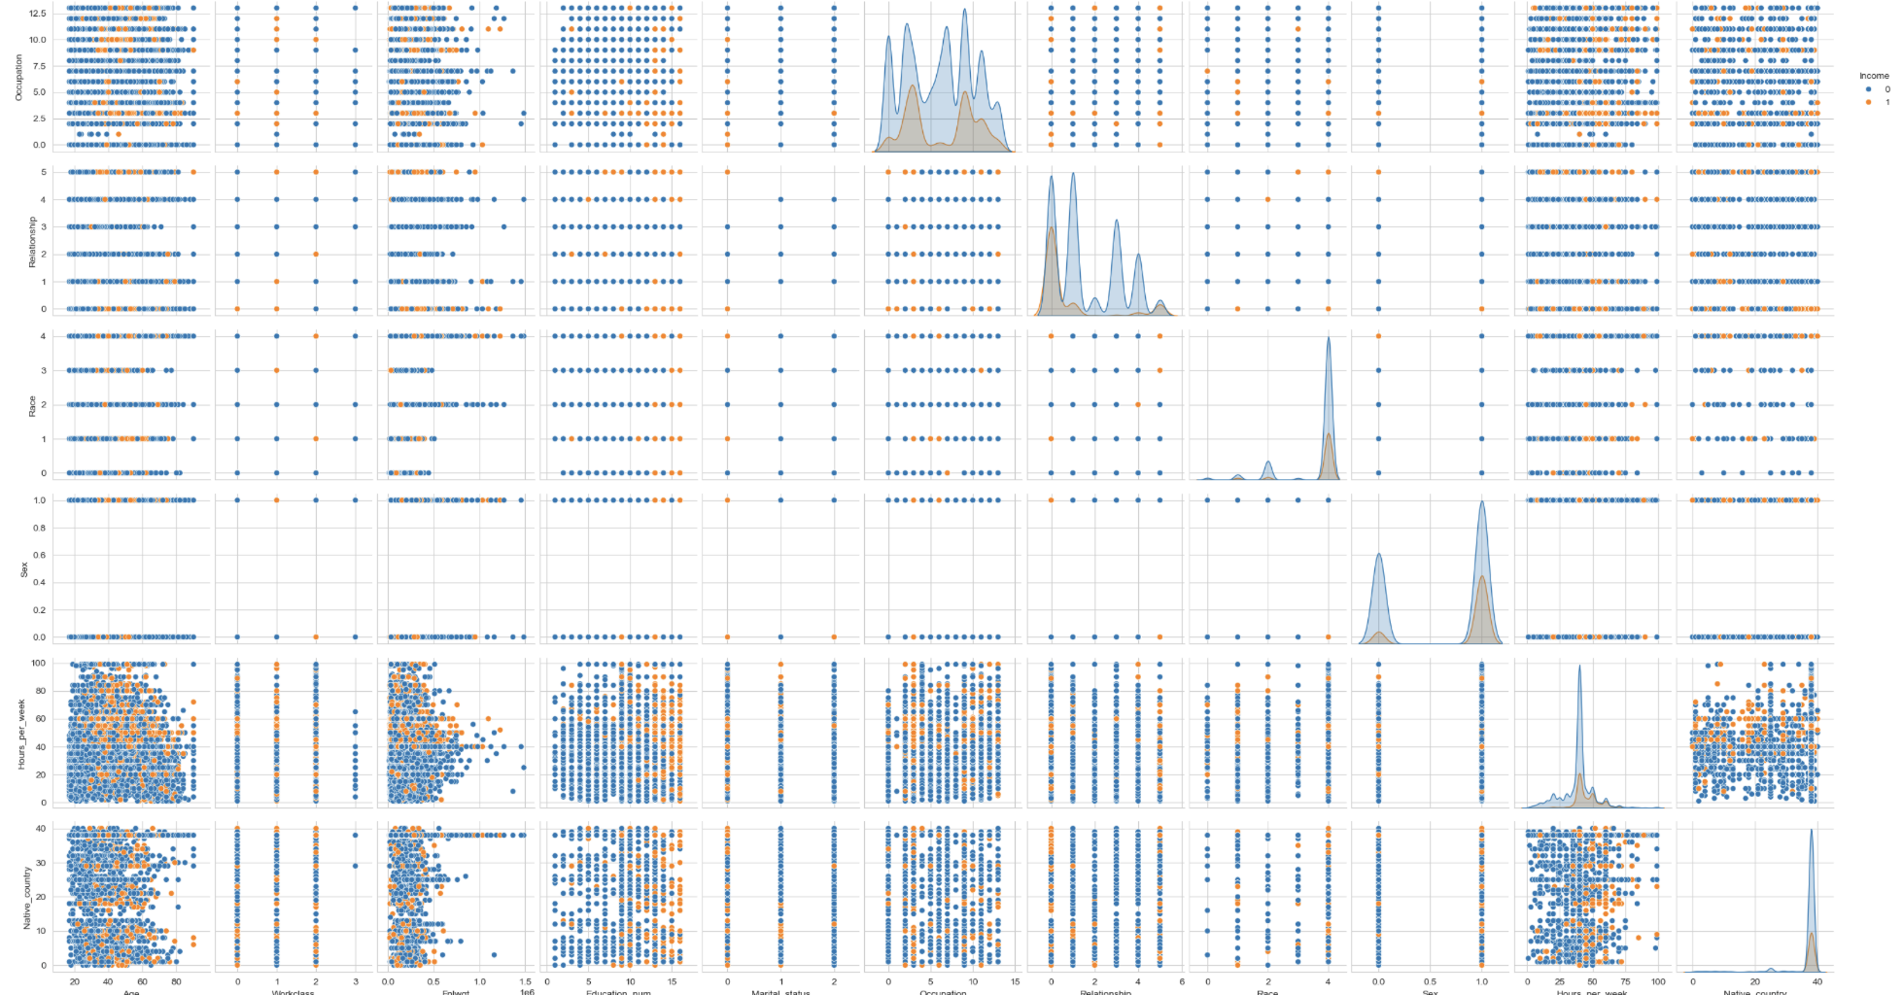

**Encoding the categorical data:**

Now, I must encode the object type data as we know that a machine can understand only data in numeric form. So, I will use Label Encoder to encode the object type data. The data are categorical type, so I am using Label Encoder.

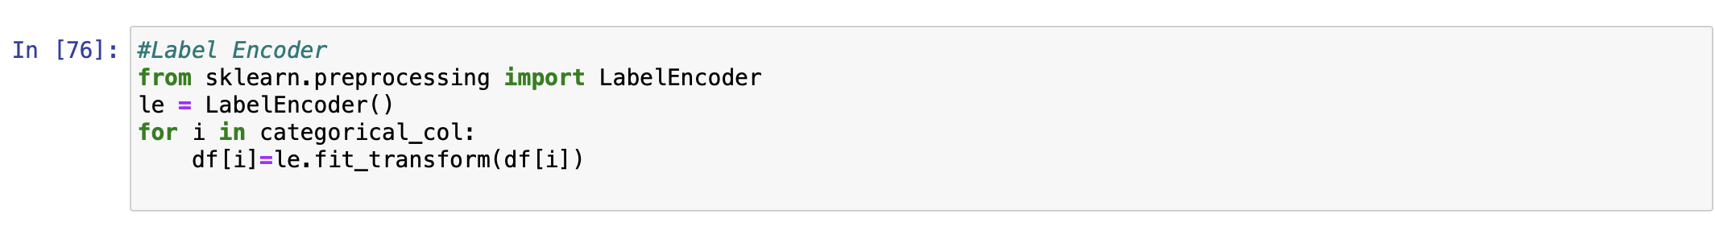

6. Let’s visualize how my data are correlated with each other and with the target variable, i.e. Income by using the corr() meathod and using the heatmap for the visualization of corr matrix.

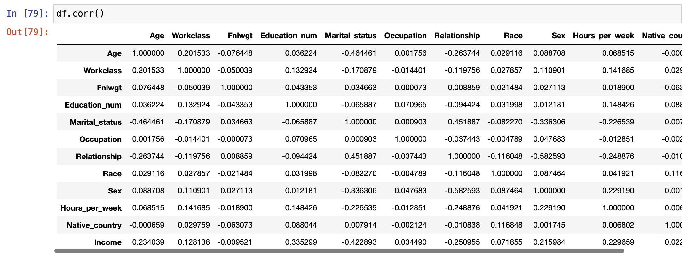

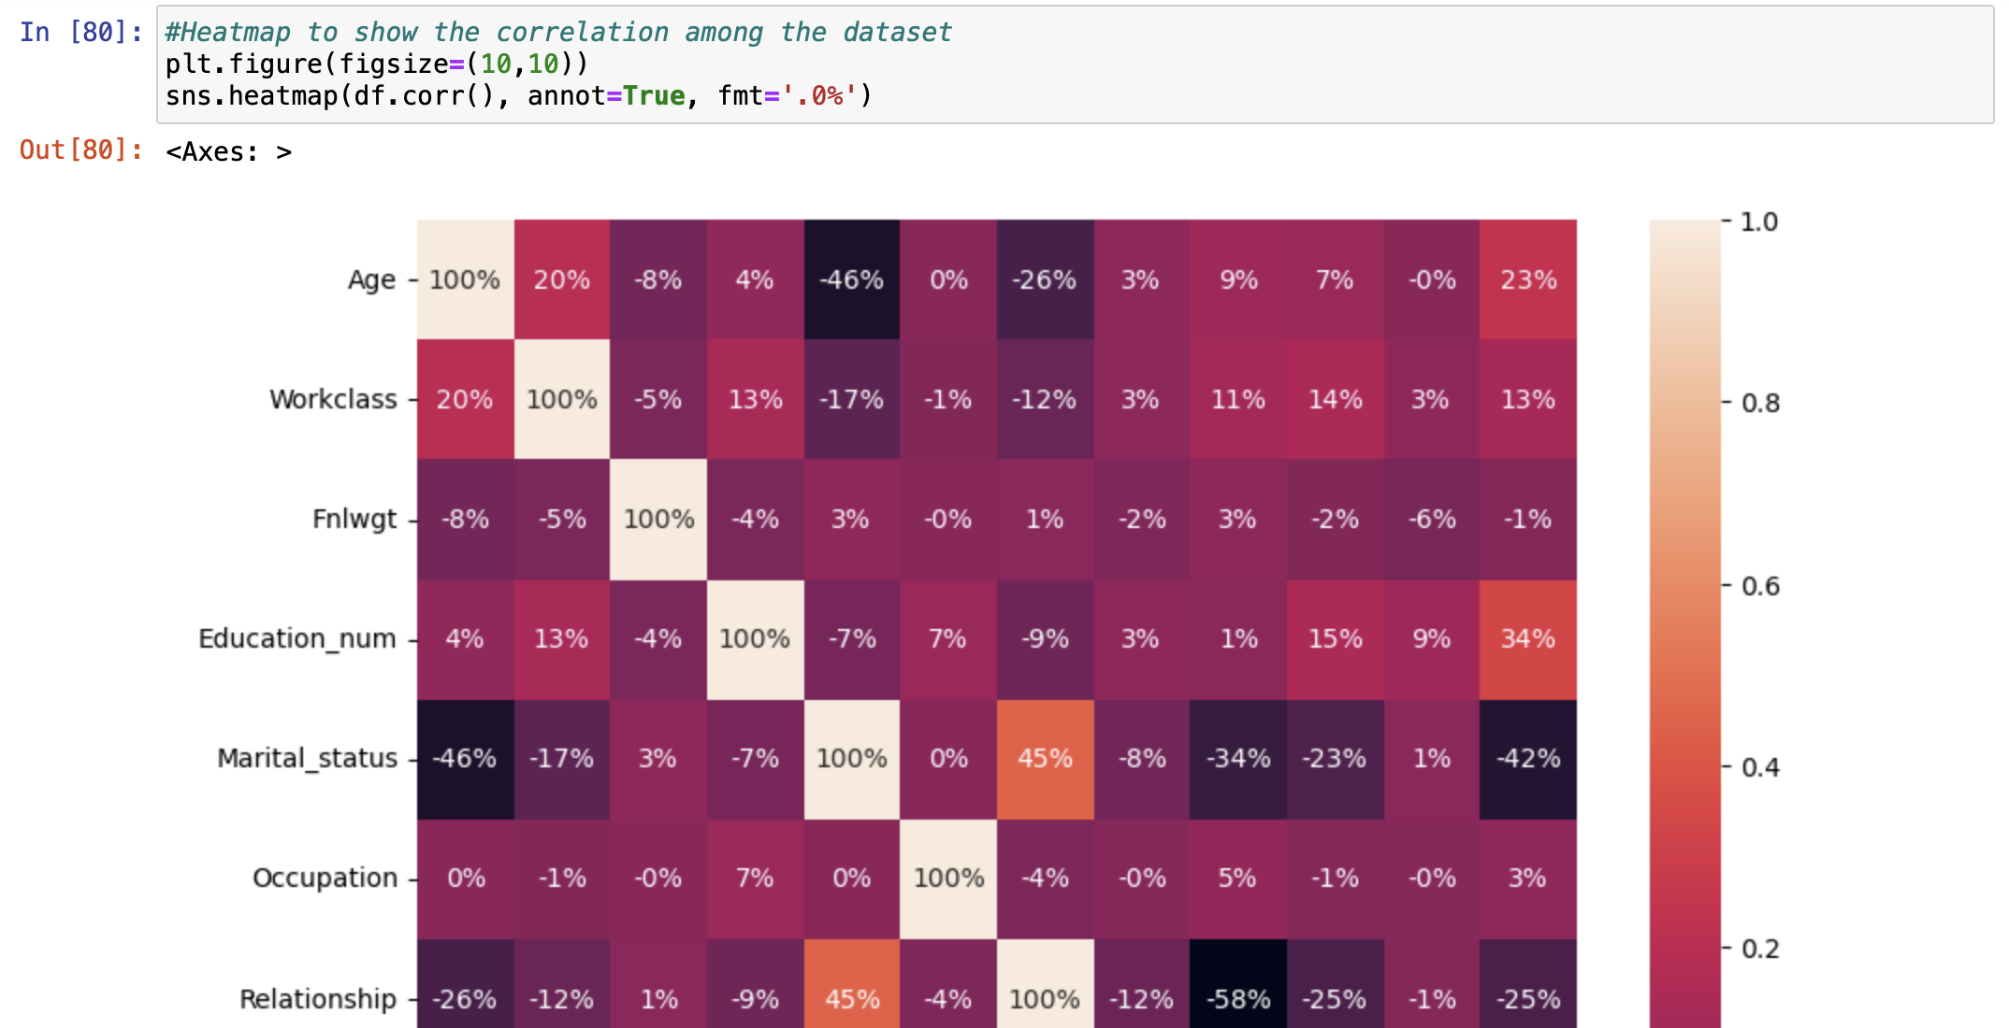

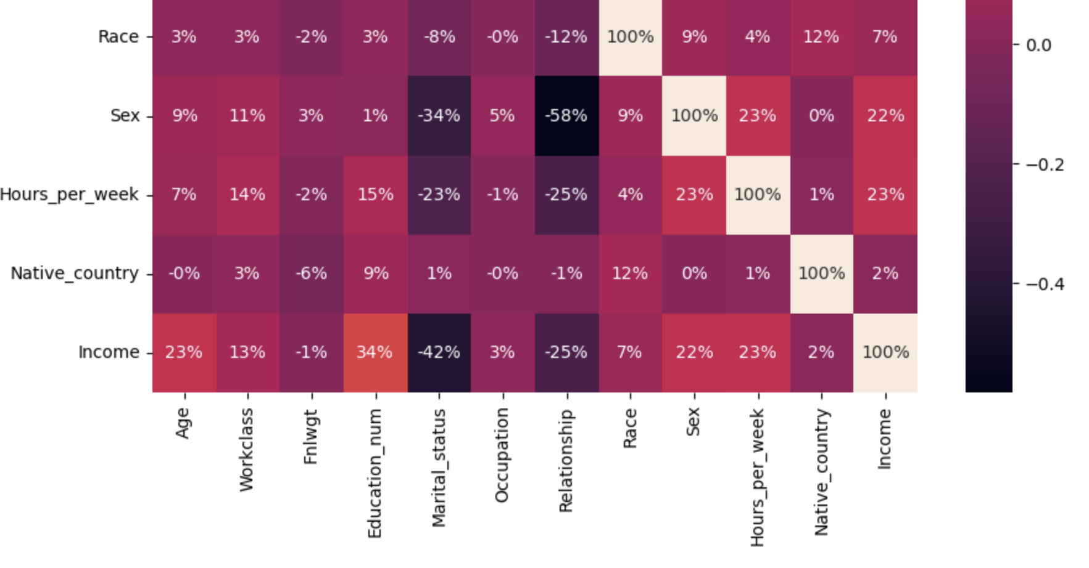

7. I will now go through the statistical summary of the dataset. I can draw some conclusions looking at the mean and standard deviation whether any outliers are present in the dataset or not. I think there are some outliers in the data and some skewed data present. I will look deep into it in my future steps.

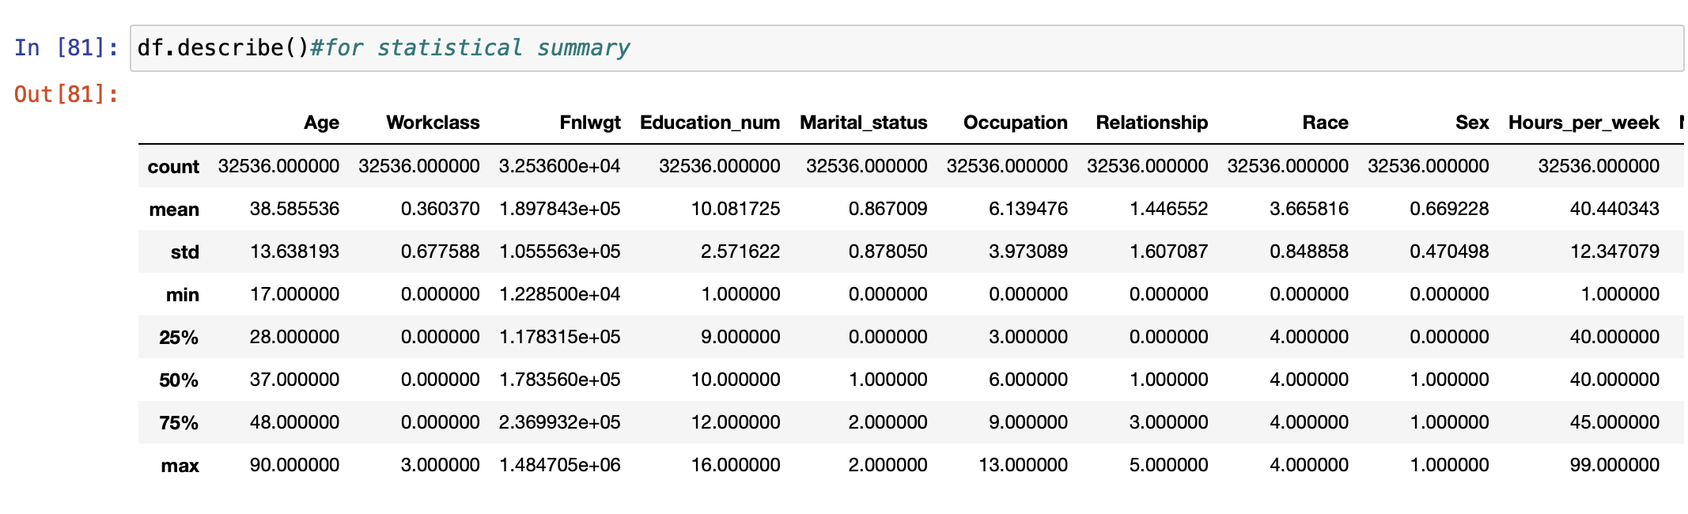

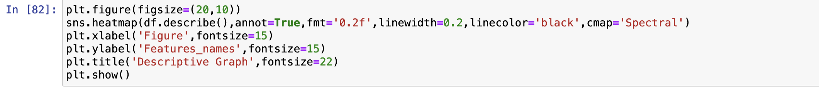

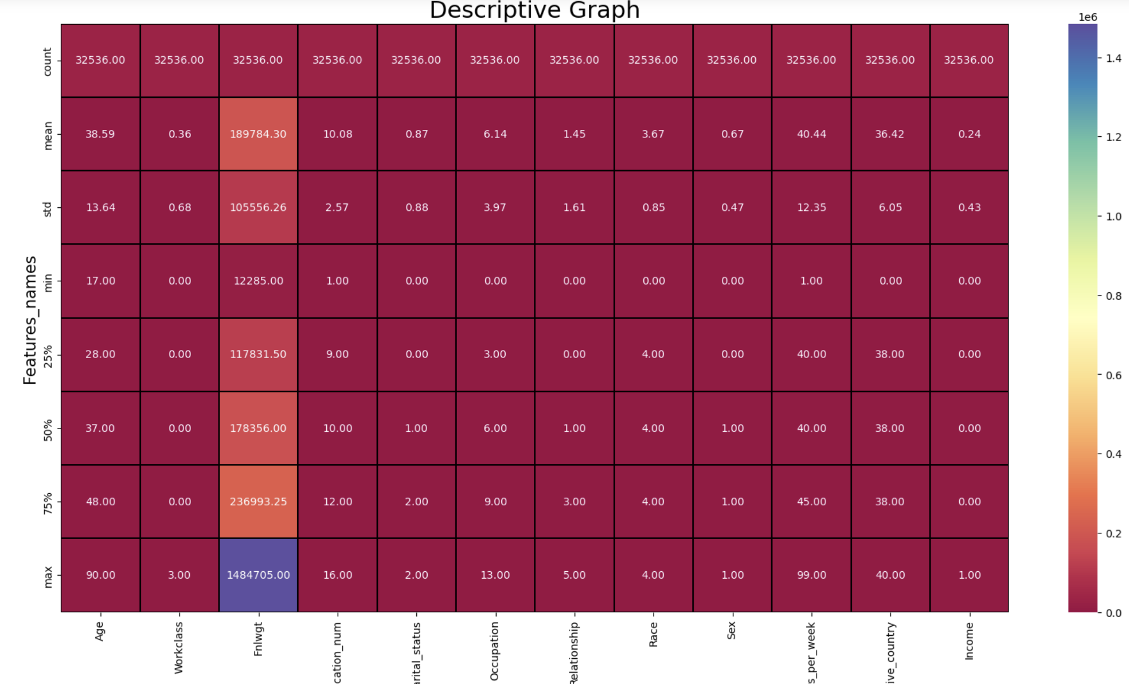

8. According to me, my data is cleaned to 60%. Now let’s check for outliers if any. I will check outliers using boxplots.

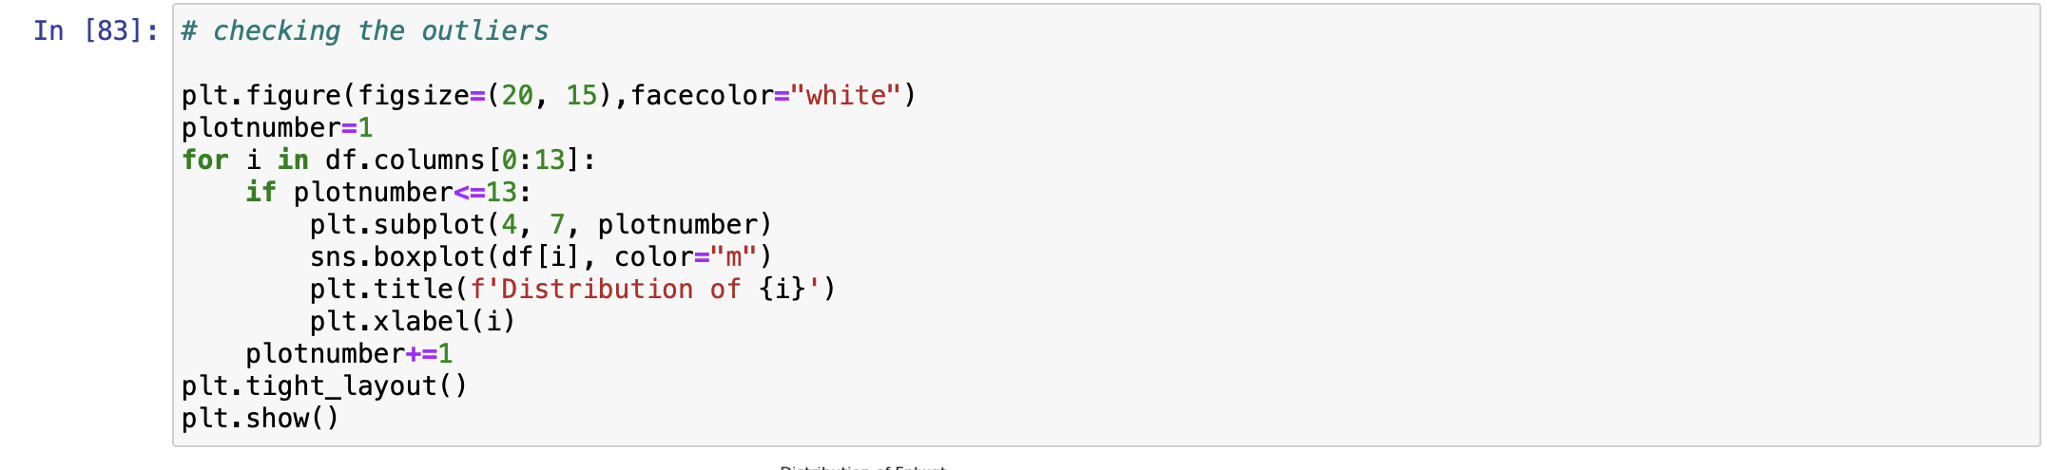

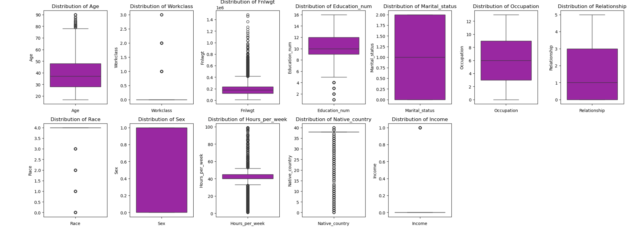

From above image, we can clearly see that there are number of black dots in most of the column which are referring to the outliers, so it means most of the data are outside the distribution. Now I will remove them using zscore method.

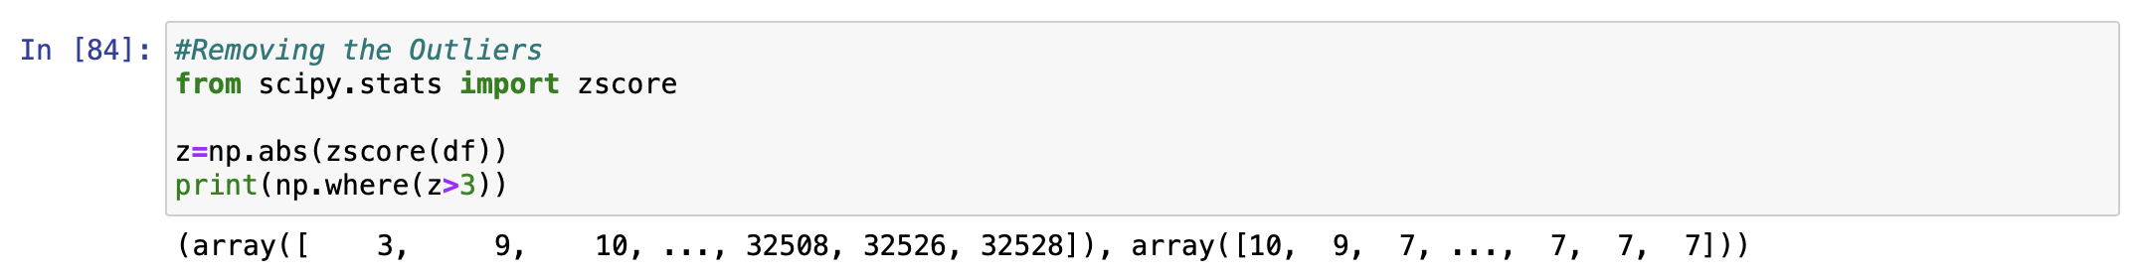

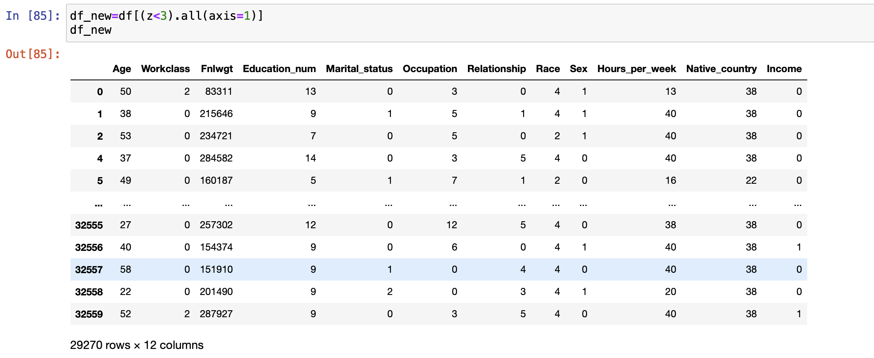

I will check what is the new shape of the dataset after outliers removal.

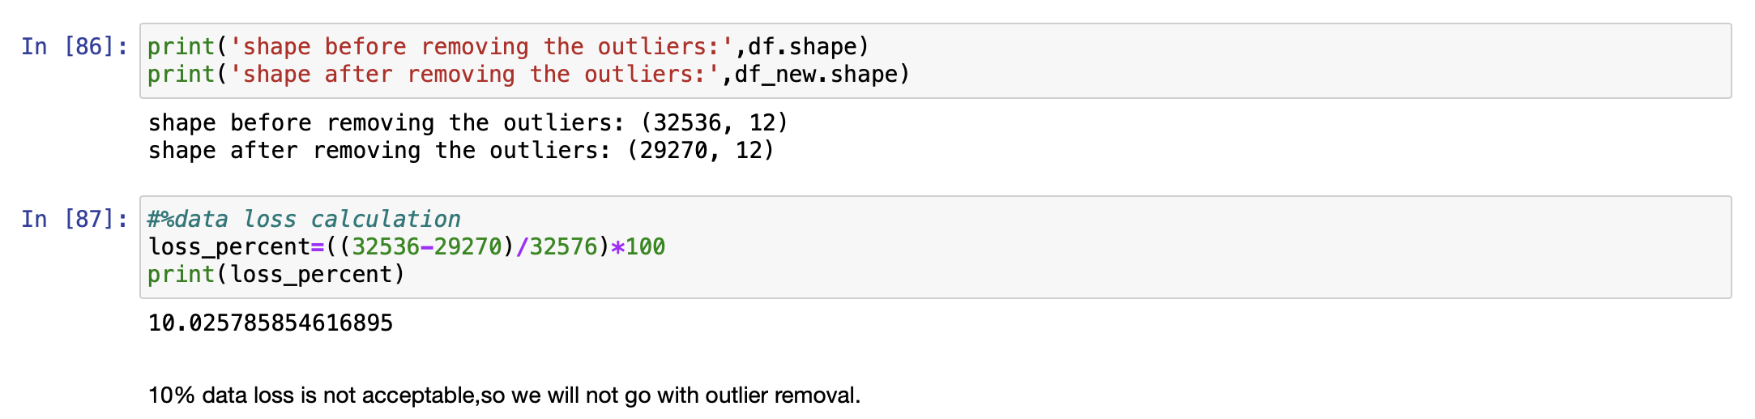

The new shape of my dataset is (29270,12) means rows are 29270 and columns are 12. We have lost 10% of our data during this process of outlier removal. But 10% of data loss is not acceptable and now I can not proceed with new shape data.

9. I will have a look on my skewed data now. I must minimise the skewness in my data if any before machine building.

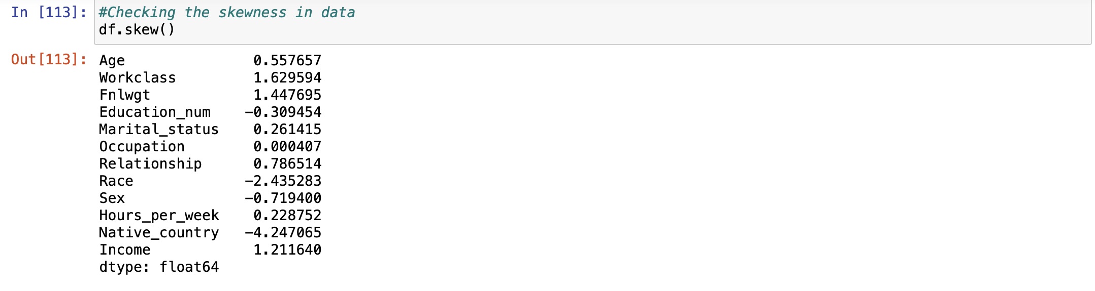

By looking at the data, I can say skewness is present in some columns. But I will not remove skewness from categorical columns but have to remove skewness from float type columns.

I am using ‘log1p’ method for skewness removal, we can also use power transform function for removing skewed data from the dataset.



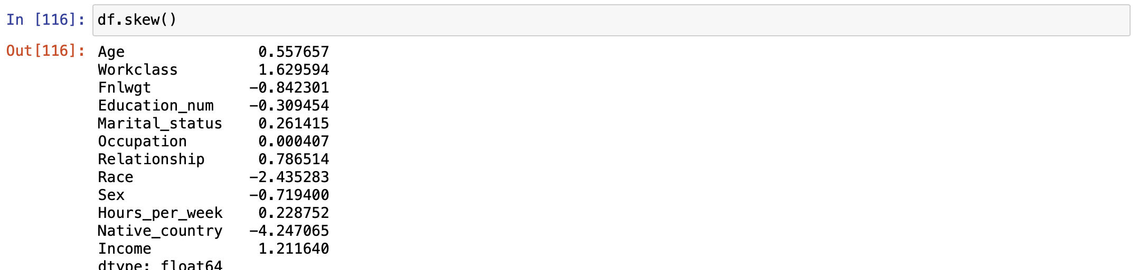

I have applied this method on selected columns and minimise the skewness in my data.

10. Now Let’s check the multicollinearity of the columns of the dataset. I will use the variance_inflation_factor method for checking the multicollinearity between the columns.



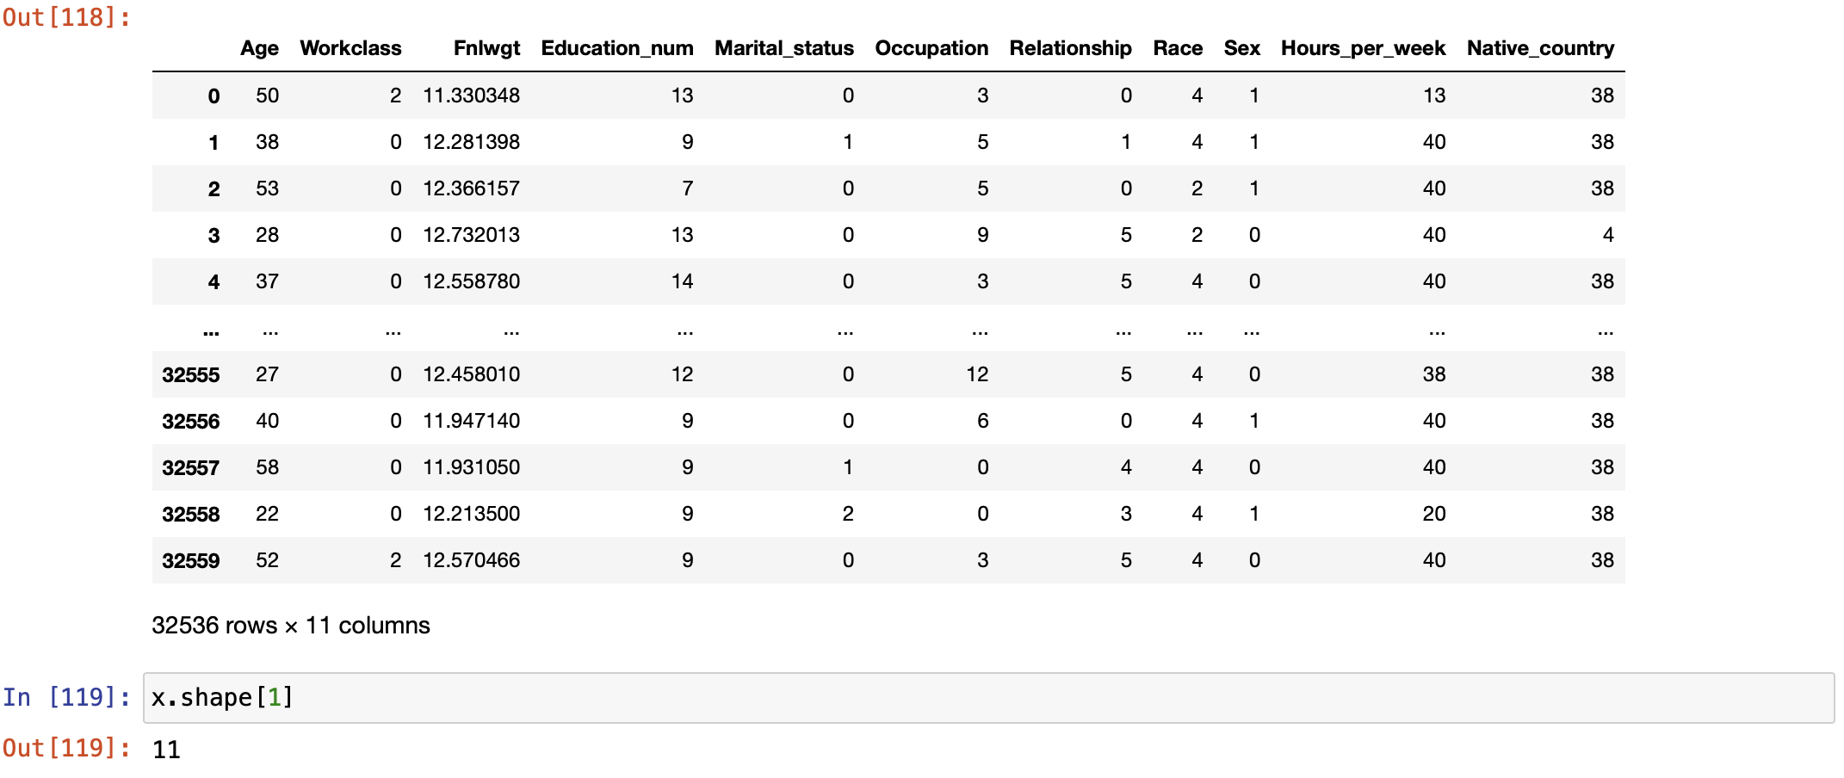

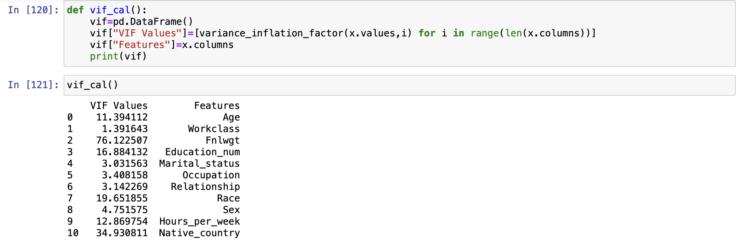

We can see clearly the Fnlwgt columns have the highest VIF value . So we dropped the Fnlwgt column. Then again check the vif for other columns.



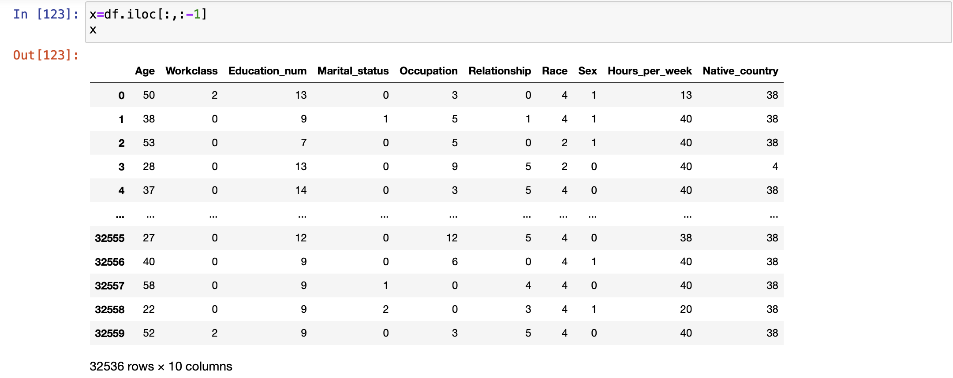



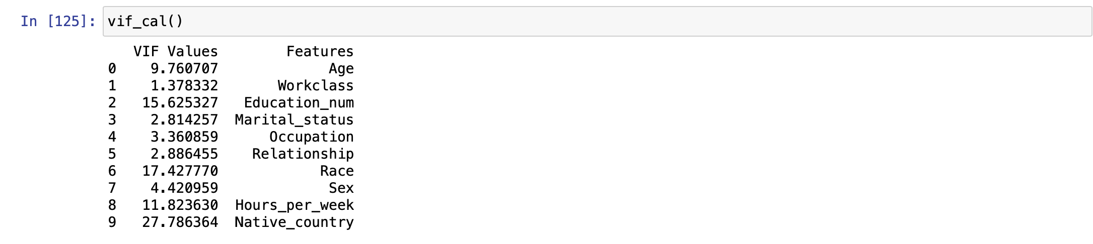

Now Data cleaning is completed. My data is getting ready for machine building process.

Before I start building the Machine Learning model, I will split my independent data and dependent data into x and y. Then I will scale the data to a standard form using StandardScaler and then resampling the dataset by using SMOTE.

**Splitting the data into x and y:**



**Scaling the data using StandardScaler:**

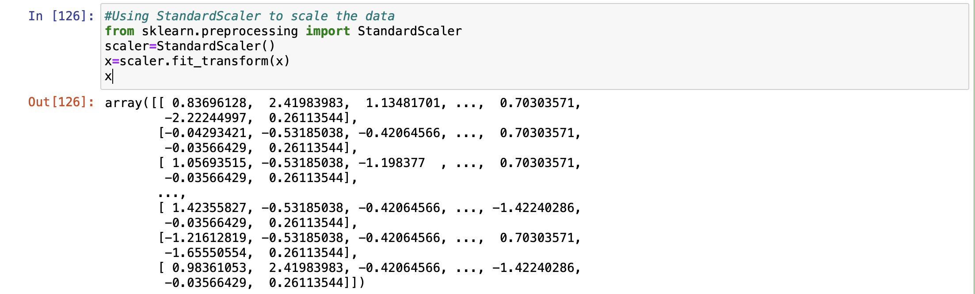

**Resampling or Oversampling by SMOTE for balancing the dataset:**

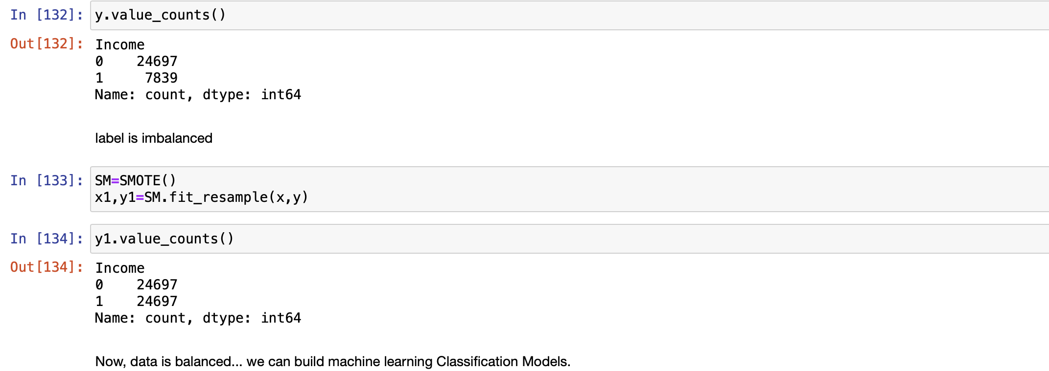

After using the SMOTE, our dataset has been balanced. Now we can build our machine learning model.

**EDA concluding remark:**

After going through data analysis and data processing, I can conclude that the raw data that I have received is now cleaned and is ready for Machine Learning process. Steps that I follow are listed below:

1. At the beginning, I have analysed the data by checking its shape, its datatypes and information regarding presence of null values, missing values and duplicate values.
2. After checking for null values, I have seen that there are no null values present.
3. After checking the missing values, I have seen that there are missing values present in three columns So first i replaced the missing values into null values and then i removed them using SimpleImputer method with mode strategy.
4. After checking the duplicates values, I found that 24 duplicated rows are present. Then I dropped all 24 duplicated rows from the dataset.
5. I have also checked the duplicates columns. I found 2 similar columns with different datatypes. So I dropped “Education” object datatype column.
6. I did the feature engineering with two columns i.e. Workclass and Marital_status.
7. I also visualized the data by using countplot, barplot and pairplot for univariate analysis, bivariate analysis and multivariate analysis.
8. While checking for datatypes, I have seen many object type columns are present, I have encoded them into numeric so that Machine can understand. The encoding process that I have used for categorical type data is Label Encoder..
9. Then I have checked the statistical summary of the dataset and checked the correlation between the features and the target variable using heatmap.
10. I tried to remove the outliers present in the dataset using Zscore method but I found that there will be 10% of data loss which is not acceptable so we proceed further without removing the outliers.
11. Then I have minimised the skewness in data using ‘log1p’ method.
12. Then I checked the multicollinearity between the columns and If the vif values is higher than 5 then we have to remove the particular column. After checking the vif, i have seen that Fnlwgt have the highest vif value so I dropped the particular column and again checked the vif for multicollinearity between other column.
13. When my DataFrame gets ready for Machine Learning process, I have split the independent variables and target variable into x and y.
14. Then I scaled my data into a standard form using StandardScaler and balanced the dataset by using the SMOTE.

**Building Machine Learning Models:**

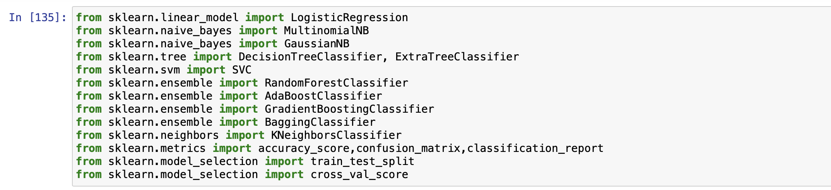

First I will find the random state for building the model and then build the model.

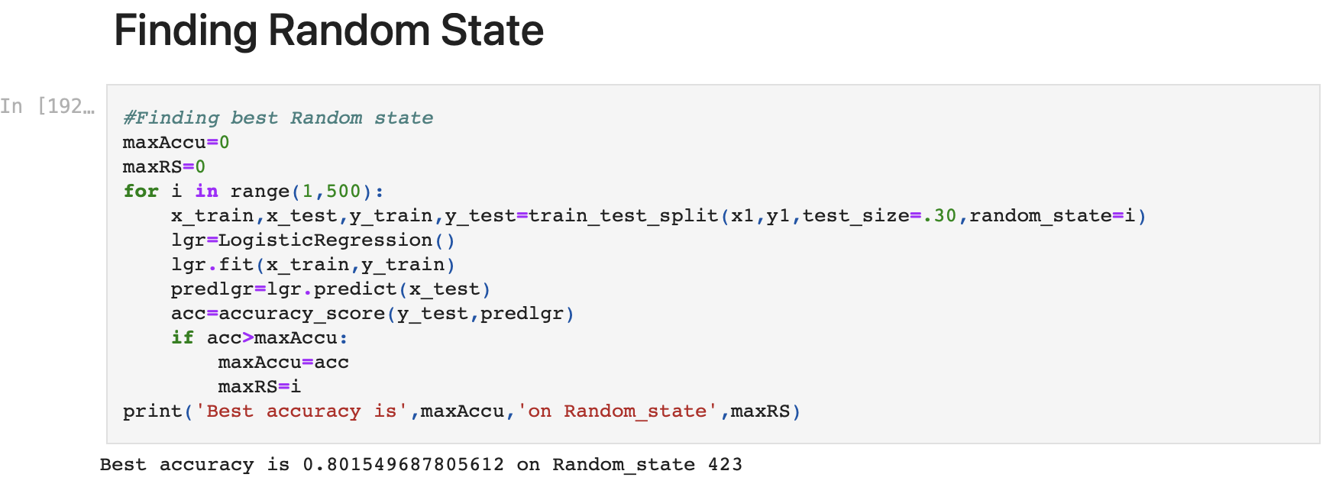

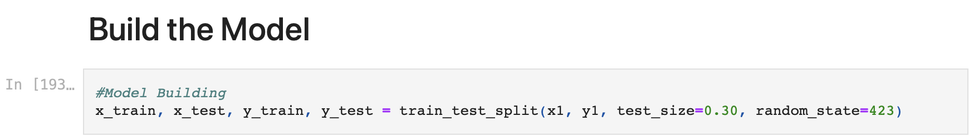

Now I will train several Machine Learning models and compare their results and find that which model give the highest accuracy which may be come due to overfitting. So I will also use cross validation to check the minimum difference between accuracy score and cross validation score.

**K Fold Cross-Validation:**

K-Fold Cross Validation randomly splits the training data into **K subsets called folds.** Every row represents one training + evaluation process. In the first row, the model gets trained on the first, second and third subset,fourth and evaluated on the fifth. In the second row, the model gets trained on the second, third, fourth and fifth subset and evaluated on the first. K-Fold Cross Validation repeats this process till every fold acted once as an evaluation fold.

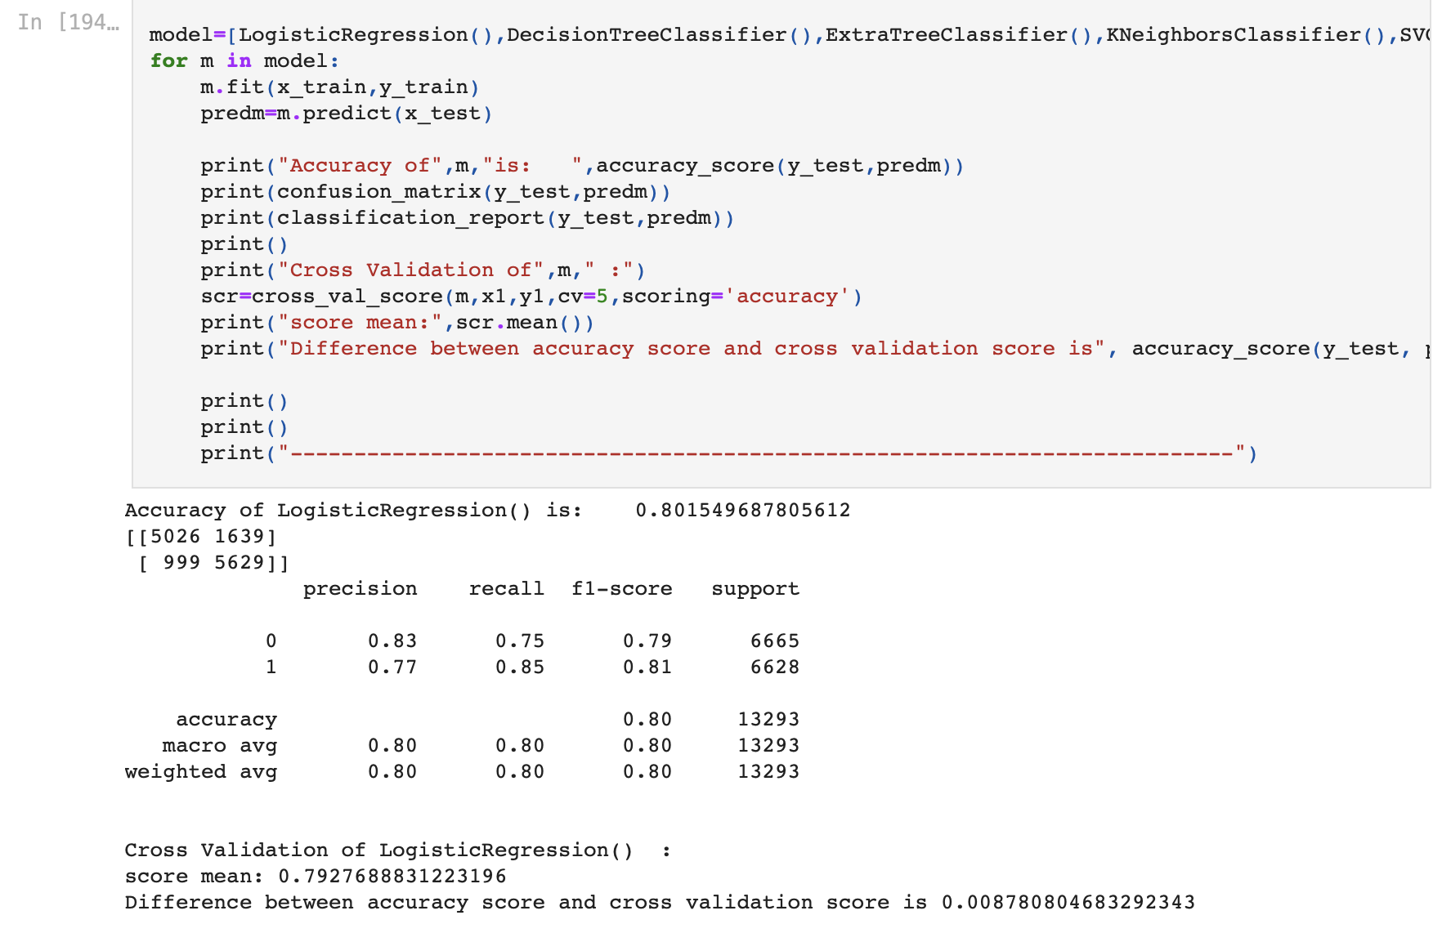

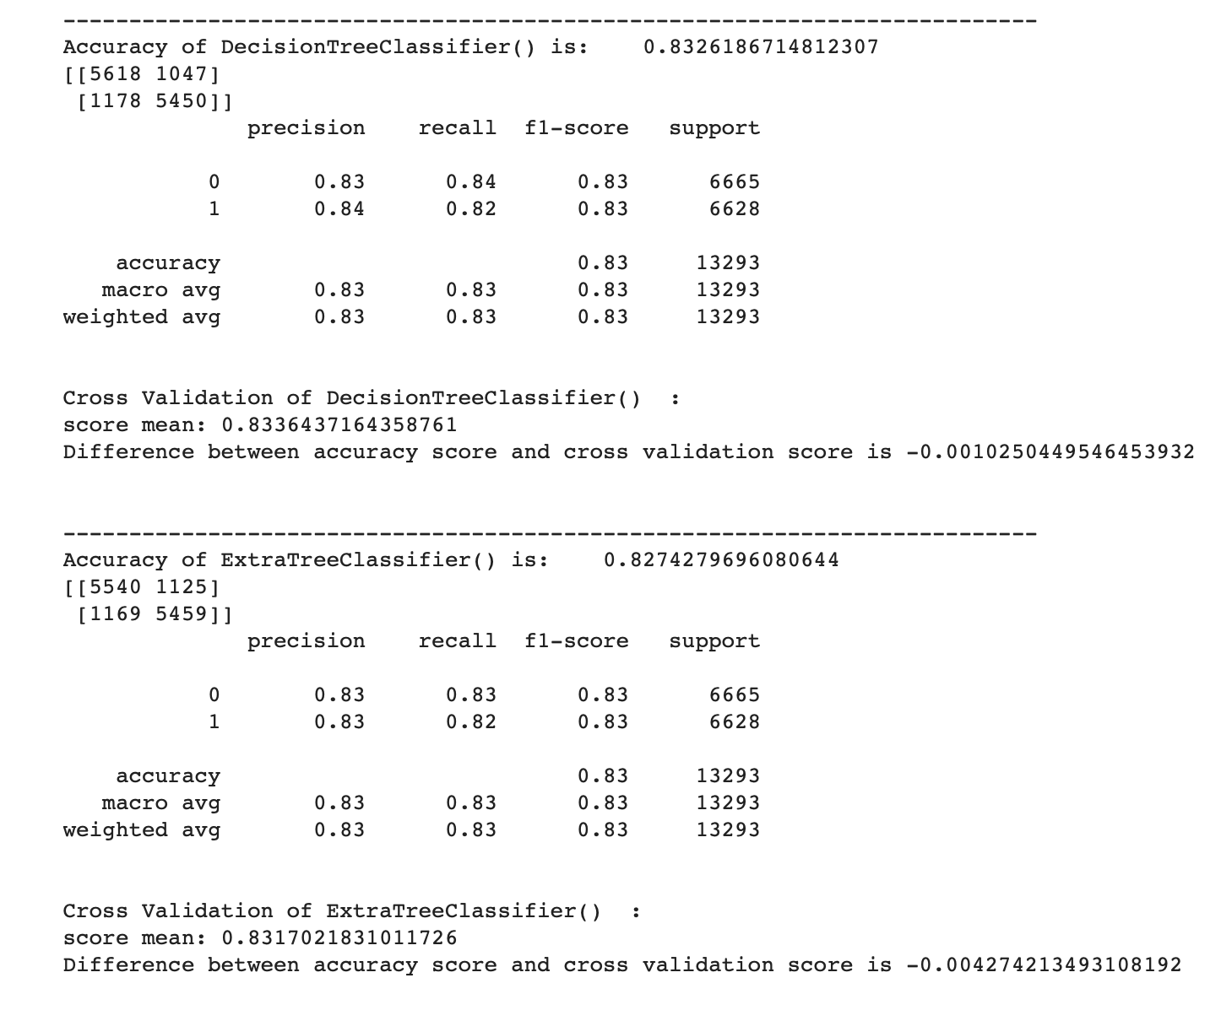

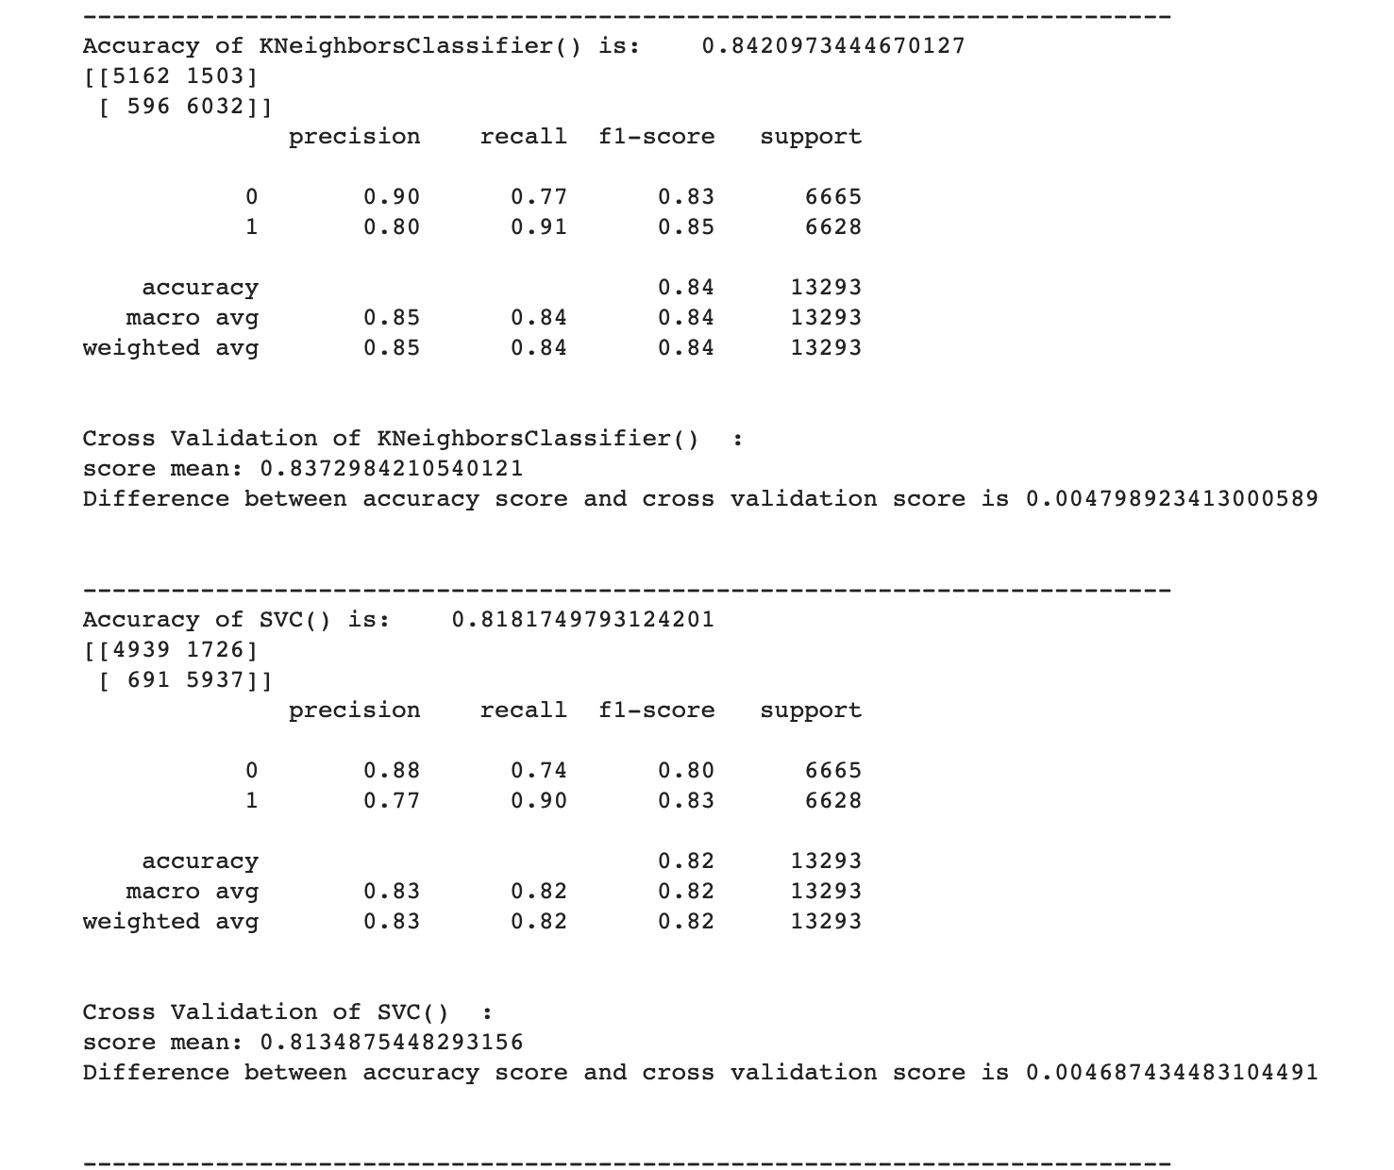

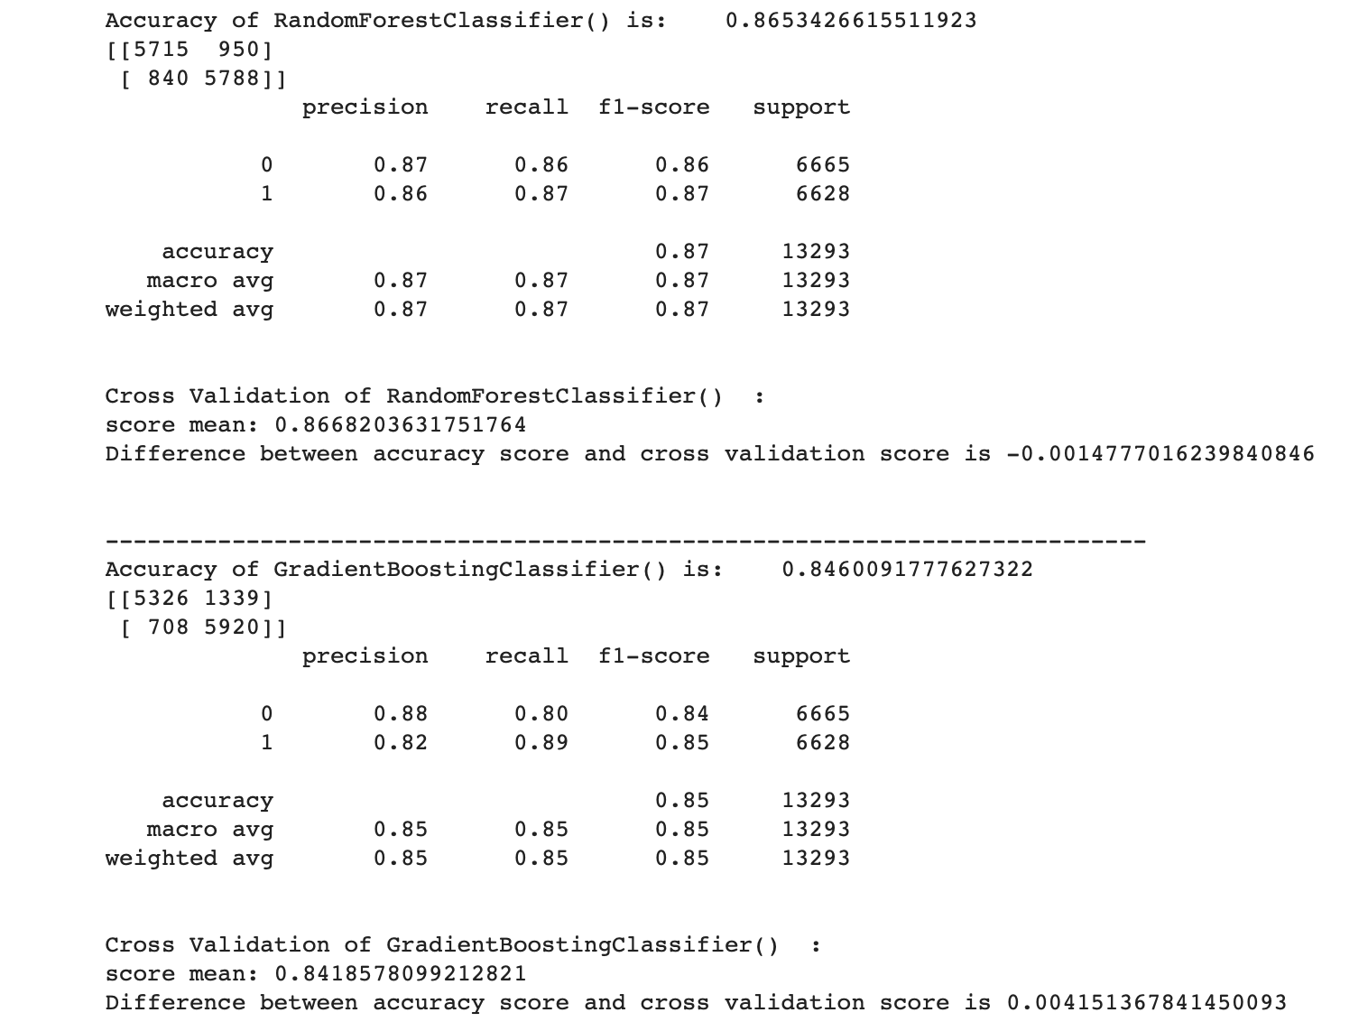

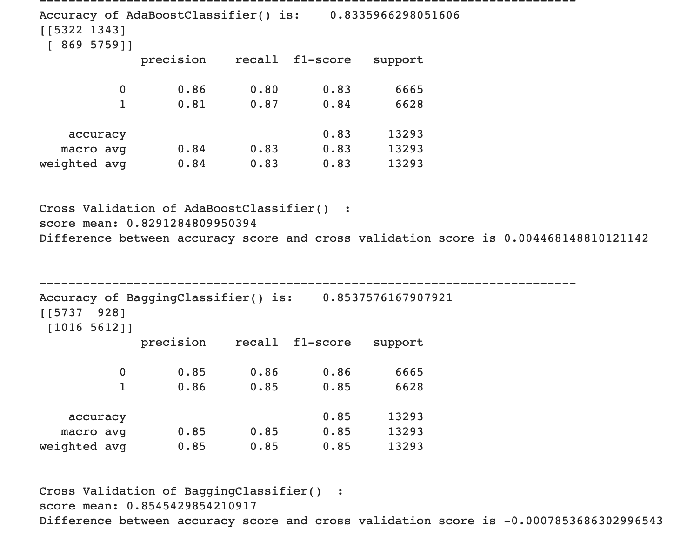

RandomForestClassifier model has the highest accuracy which is 86.73% among all the classification models at a random state 423 (this may be due to overfitting). so we also checked the cross validation of each model for actual accuracy. After Cross Validation, we found out that the minimum difference between the accuracy score and cross validation score is given by Bagging Classifier(). Final model is Bagging Classifier which has the 85.45% actual accuracy (accuracy score).

**Hyperparameter tuning:**

A Machine Learning model is defined as a mathematical model with several parameters that need to be learned from the data. By training a model with existing data, we can fit the model parameters. However, there is another kind of parameters, known as **Hyperparameters**, that cannot be directly learned from the regular training process. They are usually fixed before the actual training process begins. These parameters express important properties of the model such as its complexity or how fast it should learn.

Models can have many hyperparameters and finding the best combination of parameters can be treated as a search problem. Two best strategies for Hyperparameter tuning are:

* **GridSearchCV:**

In GridSearchCV approach, machine learning model is evaluated for a range of hyperparameter values. This approach is called GridSearchCV, because it searches for best set of hyperparameters from a grid of hyperparameters values.

* **RandomizedSearchCV:**

RandomizedSearchCV solves the drawbacks of GridSearchCV, as it goes through only a fixed number of hyperparameter settings. It moves within the grid in random fashion to find the best set hyperparameters. This approach reduces unnecessary computation.

Now I will try to tune the hyperparameters and check if we can increase the model's accuracy.

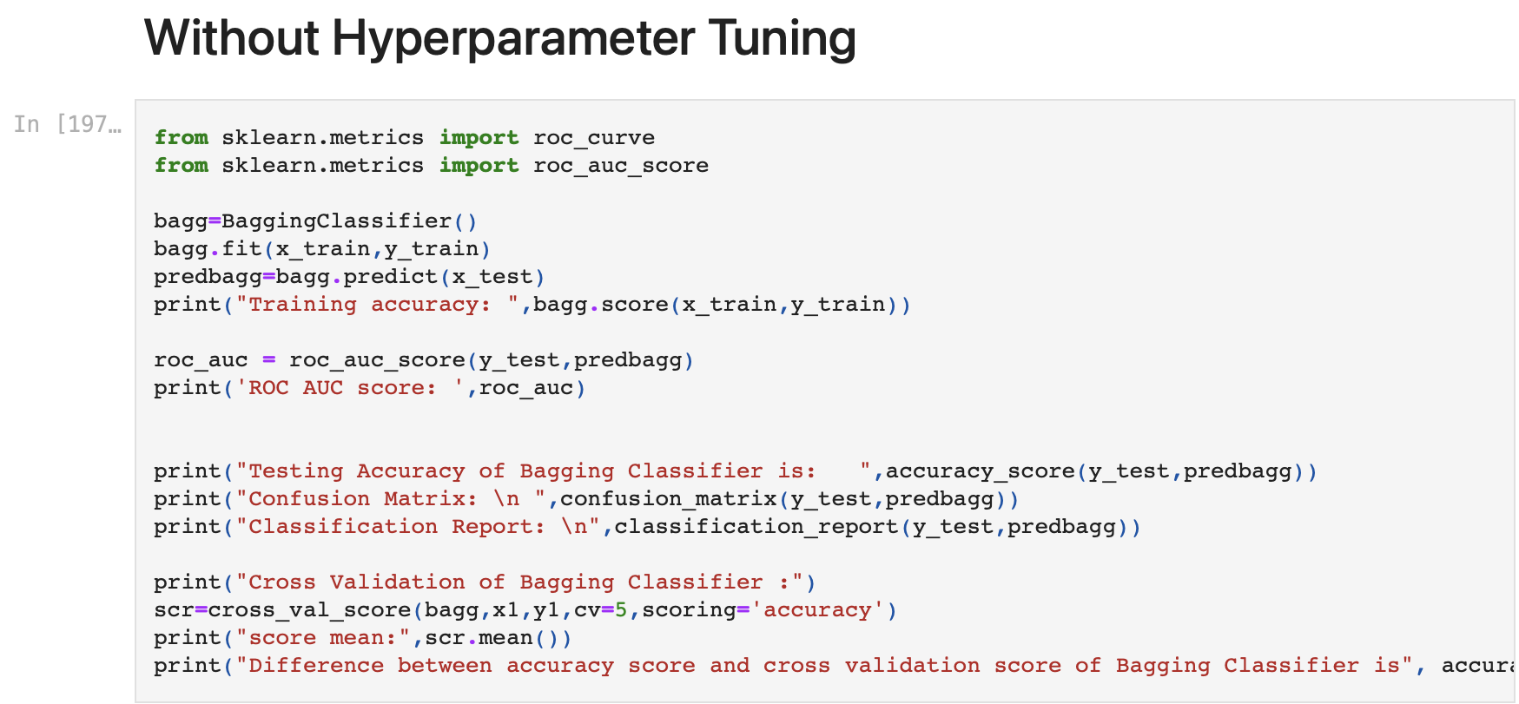

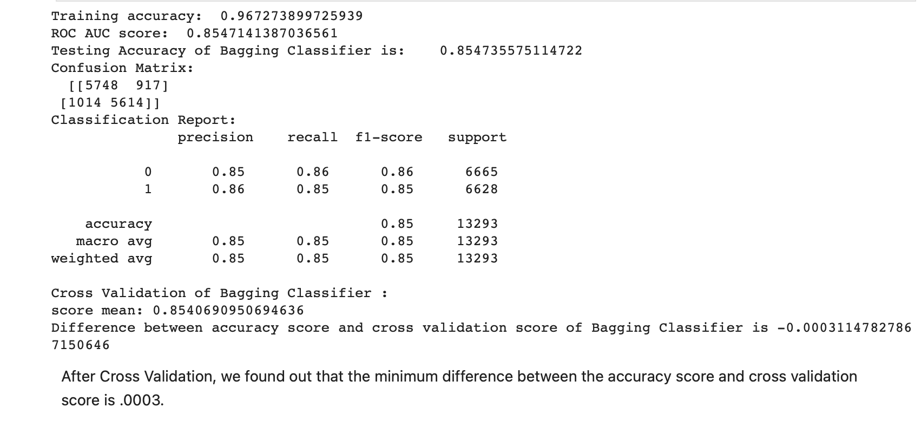

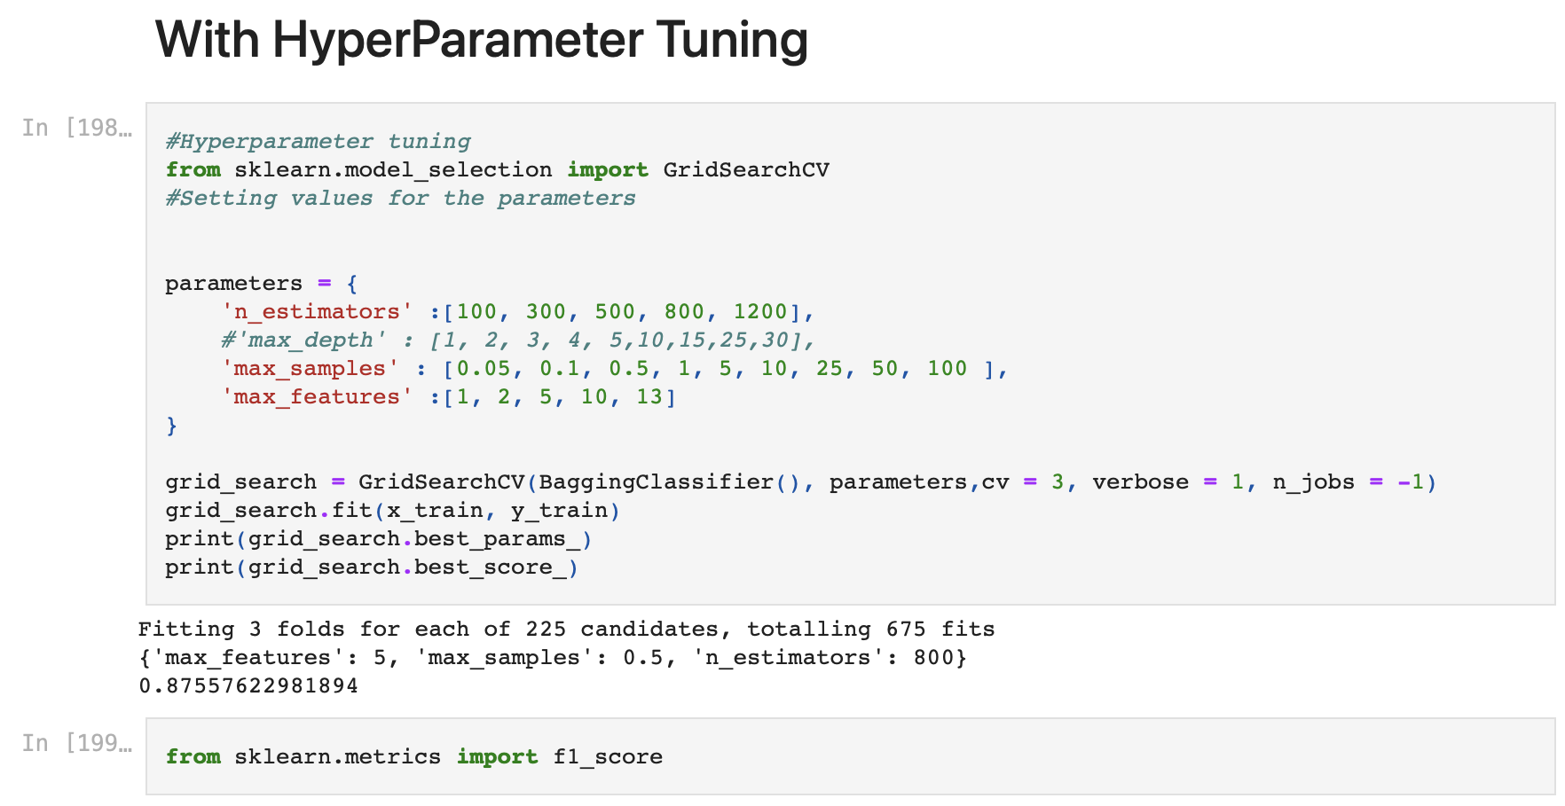

The accuracy after hyperparameter tuning is also 87%. That is increased by 2%. The best parameters are {‘max_features’:5, ‘max_samples’:0.5, ‘n_estimators’:800}.

Now,I will fit the hyperparameters into the Bagging Classifier model.

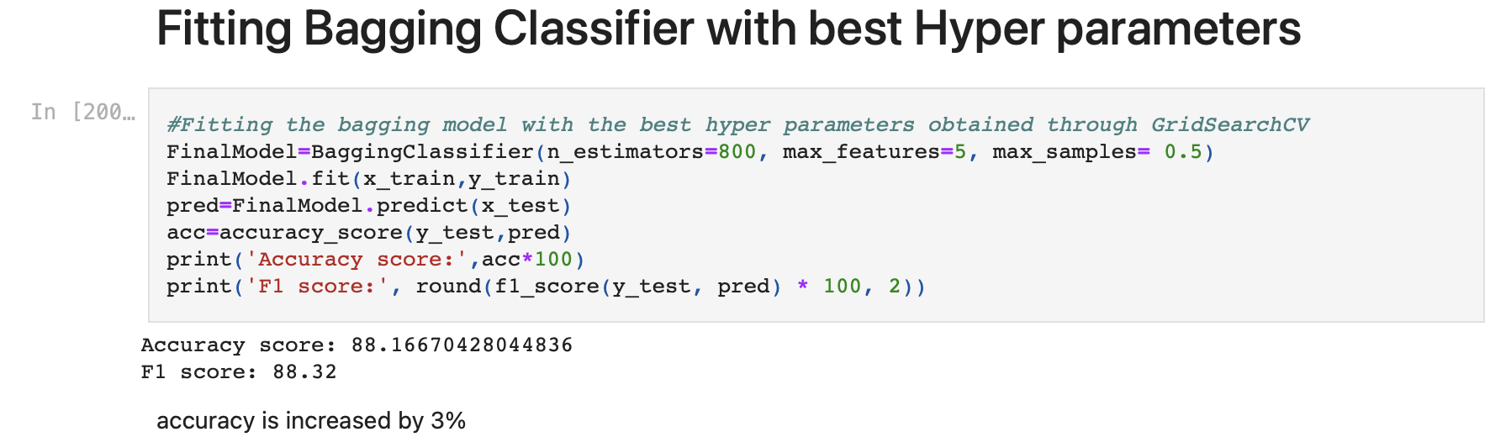

**ROC AUC Curve:**

Another way to evaluate and compare our binary classifier is provided by the ROC AUC Curve. This curve plots the true positive rate (also called recall) against the false positive rate (ratio of incorrectly classified negative instances).

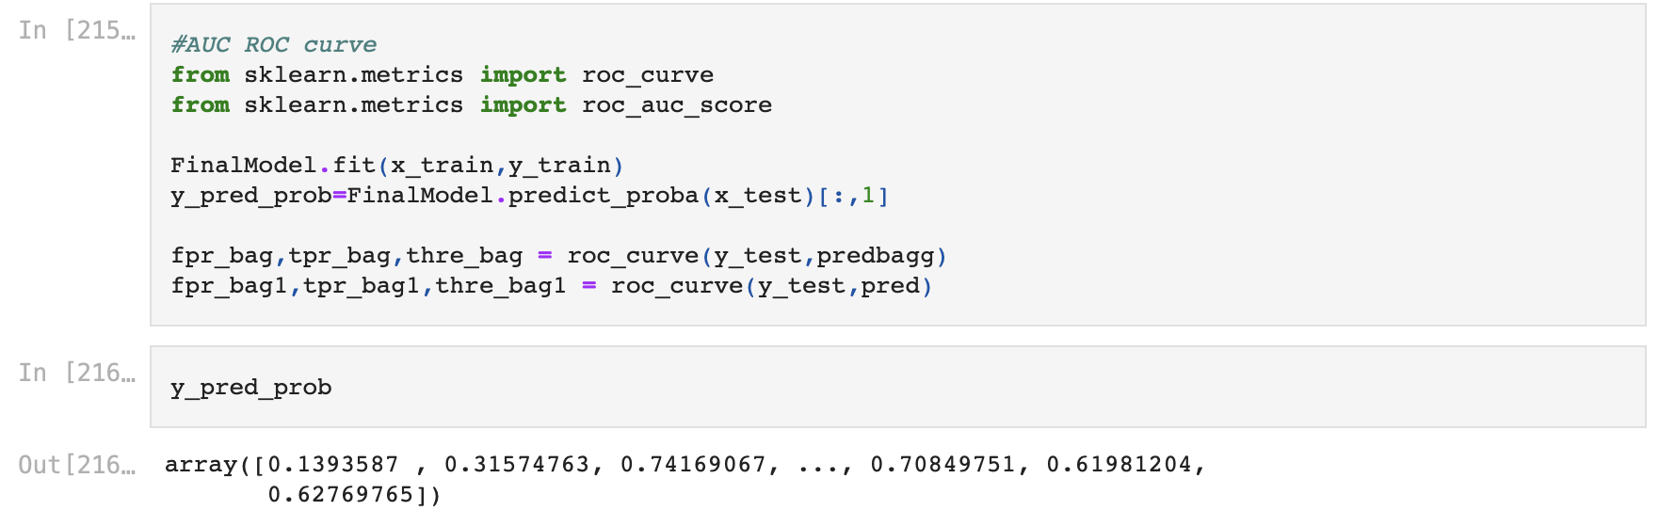

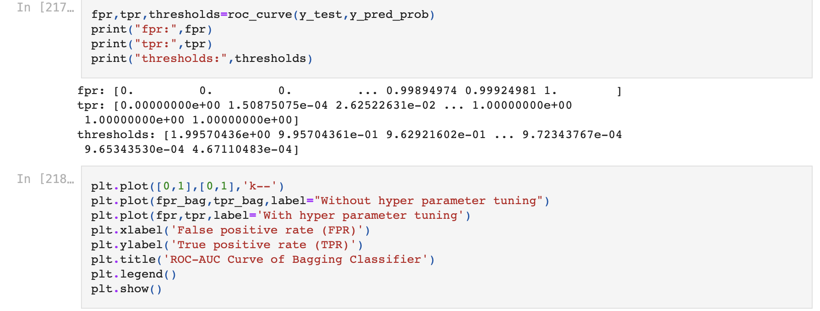

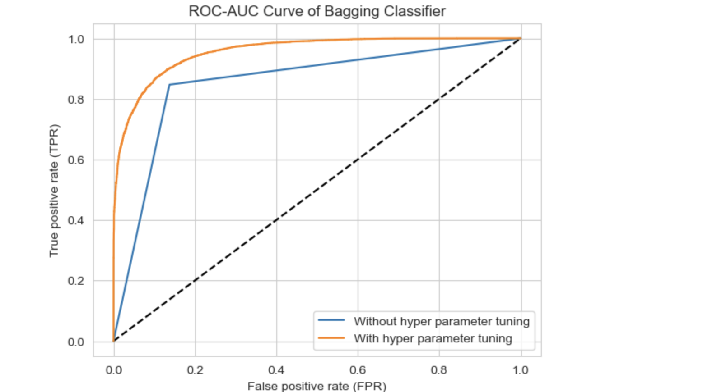

The dotted line in the middle represents a purely random classifier (e.g a coin flip) and therefore our classifier should be as far away from it as possible.

**ROC AUC score:**

The ROC AUC Score is the corresponding score to the ROC AUC Curve. It is simply computed by measuring the area under the curve, which is called AUC.

A classifier that is 100% correct, would have a ROC AUC Score of 1 and a completely random classifier would have a score of 0.5

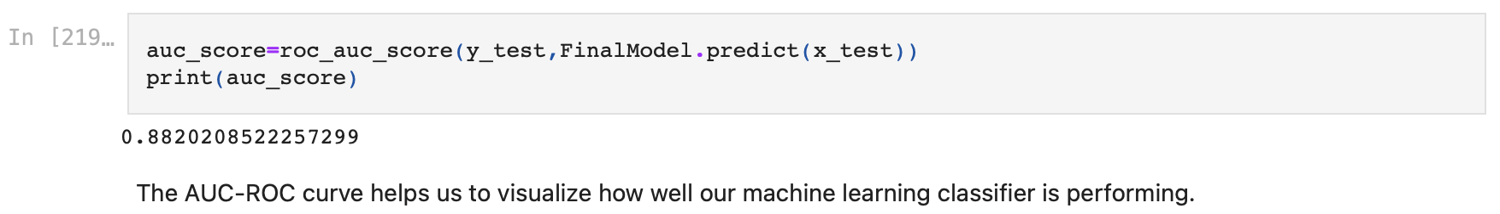

The score is 0.88202 which is enough good but not so satisfactory.

Now, I am saving the model.



I loaded the model and tried to predict the income levels.

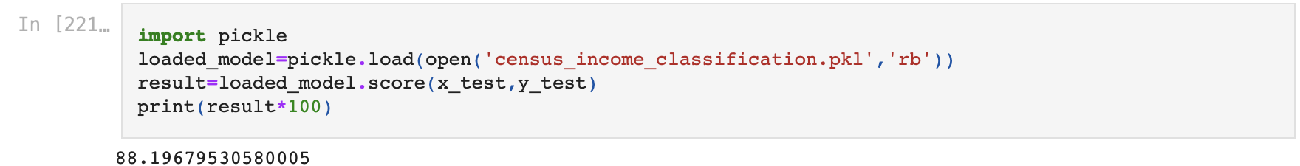

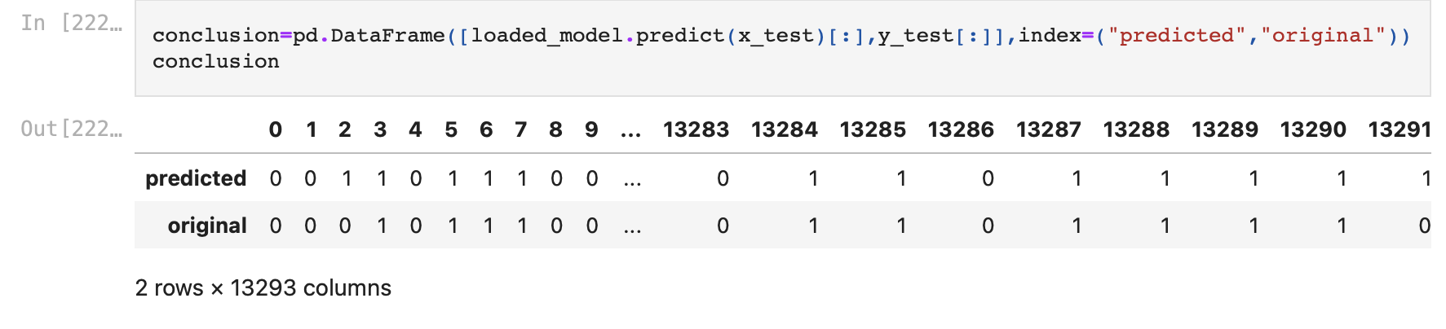

**Conclusion:**

We started with the data exploration where we got a feeling for the dataset, checked about null data, missing data, duplicated data, and learned which features are important. During this process we used seaborn and matplotlib to do the visualizations. During the data pre-processing part, we converted features into numeric ones, grouped values into categories and computed missing values. Afterwards we started training different machine learning models, picked one of them (Bagging Classifier) and applied cross validation on it. Then we discussed how Bagging Classifier works, took a look at the importance it assigns to the different features and tuned its performance through optimizing its hyperparameter values and fitted the model.

Naturally, there is still room for improvement, like doing a more extensive feature engineering, by comparing and plotting the features against each other and identifying and removing the noisy features.